A. SPECIFIC AIMS
The long range goal of this research is to provide enabling technologies for regeneration of tissue that is routinely exposed to vibration at frequencies of 10-10000 Hz. In the human body, there are two organs that receive life-long exposure to vibration, the larynx and the ear. Tissues in these organs develop specifically for mechanical vibration in normal maturation. In addition, skin on the hands and other body surfaces is sometimes exposed to vibration in industrial tool use, although normal growth and development of skin is not dependent on vibration. The problems with cochlear, vocal fold, and dermal tissue exposure to vibration have commonalities, but also major differences. In the ear, vibrational amplitudes are the smallest (on the order of 1 μm), but frequency range is the highest (up to 20,000 Hz). In the larynx, vibrational amplitudes are the highest (on the order of 1 mm), but the frequency range is smaller (up to 1000 Hz). In the skin, the exposure is much more variable and specific to an occupation or recreation. Our goal is to develop bioreactors in which tissue growth, vibrational stress delivery, and rheological testing can be performed in a single machine over a period of several days. This will be accomplished by using the combination of electromagnetic and piezoelectric technologies to enable stress application and measurement to occur in the 10-10000 Hz range, with amplitudes that are typical for vocal fold, cochlea, and dermal tissue constructs.
The overall aim of this proposal is to develop a stress application and incubation system for a bioreactor that can potentially be used to test tissue traumatization and regeneration of tissue constructs under vibratory mechanical stimuli. The uniqueness of our system is that both mechanical stimulus delivery and testing of the tissue’s viscoelastic properties will be accomplished within the bioreactor during the incubation process. The specific aims are:
1. To extend stress delivery and rheologic testing machinery of a precision commercial rheometer to a variety of tissue constructs, including, disks, ribbons, gels, fluids, and films.
2. To extend the frequency, amplitude, and duration ranges (and their programmability) toward those encountered under physiologic conditions in hearing, voicing, and hand tool use.
3. To extend incubation time from 1-2 hrs to several days.
4. To extend simple one-dimensional stress or strain regimes to compound regimes so that wave propagation phenomena in tissues can be simulated.

B. BACKGROUND AND SIGNIFICANCE
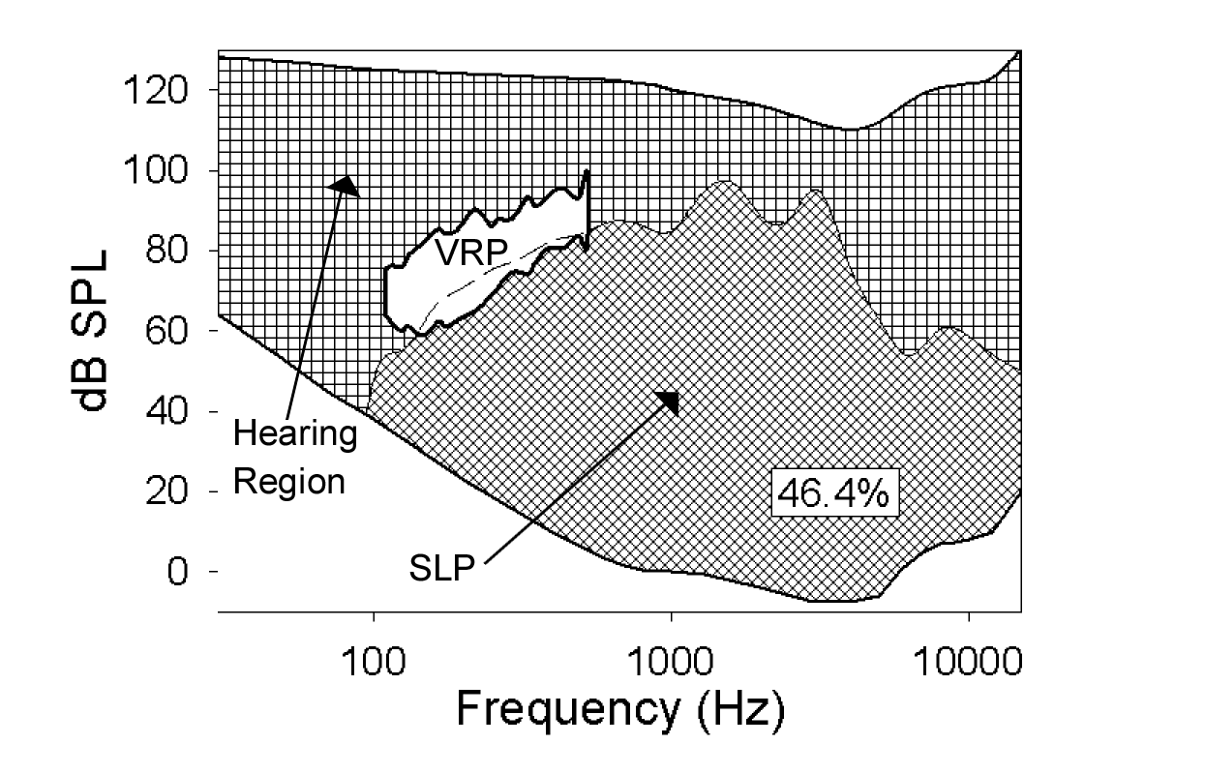
In humans, sound is produced in the larynx and received by the ear. In both organs, tissue is vibrated in the transduction of mechanical energy to acoustic energy (and vice versa). In the vocal folds of the larynx, tissue normally vibrates in the 50-1000 Hz range but can reach 4000-5000 Hz in rarely used whistle voice.¹ In the ear, tissue vibrates in the 20-20000 Hz range. The overlap of frequency and intensity between a vocalist and a listener is shown in Figure 1 for a one meter mouth-to-ear distance.² Note that the range of fundamental frequency in voicing (shown as a white region) occupies only a small portion of the hearing range, but higher harmonic frequencies of the voice can cover 46.4% of the entire hearing region at the one meter distance.
Figure 1. Hearing region with overall maximum spectral level profile (SLP) (diagonal cross-hatch) and voice range profile (VRP (white area) of a trained tenor plotted on top. Percentage of hearing range overlapped by SLP is shown in a box

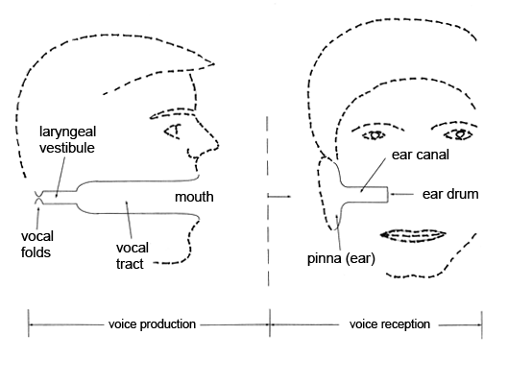
For voicing and hearing, viscoelastic biomaterials transmit energy between airborne acoustic waves and motor or sensory organs. Figure 2 shows interesting transduction symmetry between the production side and the reception side. In both cases, an air tube (about 2-3 cm in length) is narrowed to create a better impedance match to tissue vibration. This is the laryngeal vestibule on the production side and the ear canal on the reception side. Both tubes raise the acoustic impedance to approach the tissue impedances of the vocal folds or the ear drum. But this is only the peripheral phase of the transduction process. Cells and extracellular matrices (ECMs) in middle and inner ear tissues and laryngeal tissues are responsible for maintaining the mechanical properties of the biomaterials for efficient energy transmission throughout the biomechanical systems.
Figure 2. Similar air tubes used for voicing and hearing transduction

Review of Biomaterials Involved in High Frequency Vibration
The human vocal folds contain three layers of tissue that are critical for energy transfer. The outermost layer is stratified squamous epithelium (about 10-15 cell layers) that is in contact with air in respiration and phonation (Figure 3, right side).
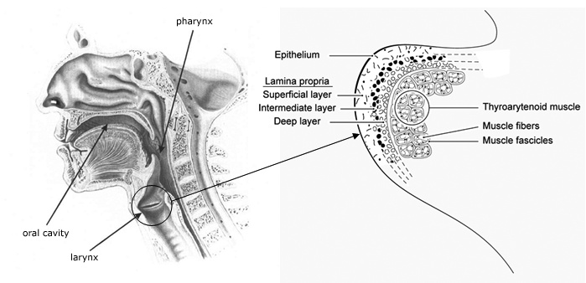
A basement membrane connects the epithelium to a soft, pliable construct known as the lamina propria. This viscoelastic construct, subdivided into superficial, intermediate, and deep layers, is responsible for efficient transfer of acoustic and aerodynamic energy in the airway to the main body of the vocal folds, the thyroarytenoid muscle. Pitch, loudness, voice quality, and ease of phonation are affected by the viscoelastic properties of these transduction tissues.³⁻⁵
Figure 3. Vocal fold location in the neck and vocal fold coronal cross-section (Adapted from Speech and Hearing Science, by Zemlin, p.220 and Principles of Voice Production, by Titze)
Viscoelastic properties of vocal fold tissues are frequency-dependent. They have been studied macroscopically,⁶⁻¹⁰ but the cellular and molecular mechanisms by which these viscoelastic properties change, are not well understood.
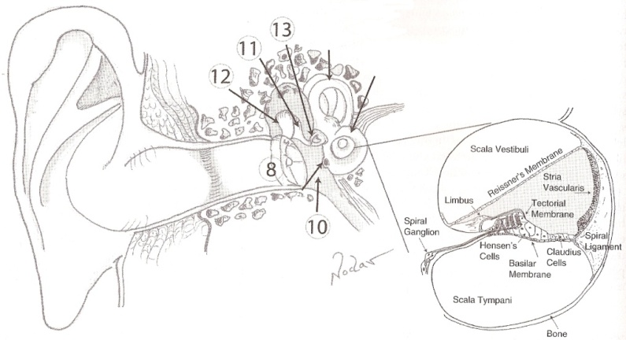
Auditory transduction of interest involves middle and inner ear systems (Figure 4). Sound pressure fluctuations travel through the ear canal to the tympanic membrane (label 8). Smooth and chaotic tympanic membrane vibrations are accompanied by 10 – 30 dB pressure gains in the middle ear.¹¹ Normal function is due to structure and viscoelasticity of the tympanic membrane. The cone and toroidal shape, its 45º – 60º angle relative to the ear canal, the orthotropic orientation of collagen fibers, and the viscoelastic properties of the tissue all contribute to the overall gain and frequency-specific gains, for pressures impinging on to the ossicular chain (labels 10-13).^{12, 13}
Figure 4. Ear anatomy and cross section of the cochlea (from The Auditory System:Anatomy, Physiology, and Clinical Correlates, by Franke, Musiek, and Baran)
Viscoelastic properties of the tympanic membrane vary across studies. Elastic moduli of cat tympanic membrane have been estimated at 100 – 300 MPa.¹⁴ Young’s modulus of cadaveric human eardrum were 0.4 – 22 MPa when subjected to low stresses (0 – 1 MPa).¹⁵ In a most recently reported finite element model, elastic moduli were chosen to be in the 1 – 100 MPa range depending on position.¹⁶ With the latter values corresponding to known anatomy, multi-modal features were generated at high frequencies that matched experimental data. But there were still anomalous features in the model. Tucker-Lee and colleagues pointed out the need to better understand the shear modulus of tympanic membranes. Modeling indicated a shear modulus of 35 MPa was needed to match experimental data, yet what is known about the microstructure suggests a much lower value.¹⁶ To date, no shear modulus measurements have been attempted, a measurement we plan to take using our rheometer-bioreactor.
The stapes footplate is the last bone in the ossicular chain. It directly contacts the oval window and entrance to the cochlea (label 13 in Figure 4). Acoustic signals transform to pressure waves that, in turn, propagate through the cochlear fluids to the membranes. Membrane movement is discretely defined by a tonotopic map, sending sound information to the brain via inner hair cells attached to spiral ganglion cells.¹⁷
Mechanical measurement, physical modeling, and computer simulation have been used to better understand passive contributions to the tonotopic map. Georg von Bekesy in 1941 and many others measured mechanical properties of Organ of Corti (floor of grayed triangle of inset, Figure 4), basilar membrane, and tectorial membranes.¹⁸⁻²² Results show stiffness of Organ of Corti diminishes by 2 orders of magnitude from base to apex, as does stiffness of outer hair cells, pillar cells, and hensen cells, and mechanical properties are orthotropic.^{18, 19} Puria and Allen were able to model input impedance by including fluid viscosity and scalae area functions as required parameters along with basilar membrane properties.²³ When scalae area was tapered and fluid viscosity was twice that of water, standing waves at frequencies ≤ 150 Hz were reduced. A real-to-life physical model of the basilar membrane coupled to a micromachined fluid structure was able to generate a tonotopic map at 4 – 35 kHz with phase accumulations of 1.5 - 3π, a phase phenomenon observed in numerous mammal studies.²⁴ Finite element modeling of the physical model generated well-matched location-specific resonances. Interestingly, both the physical model and the computer model generated standing waves near the apex when the fluid had a low viscosity of 5 centiStokes. But when a 20 centiStokes fluid was used, 20 times the viscosity of water, the anomalous standing waves attenuated. In a 3D finite element model of the external, middle, and inner ear, basilar membrane displacement and frequency response were shown to be affected by cochlear fluid viscosity. ²⁵ At both 16 mm and 25 mm from the base, displacement was halved for every decade increase in viscosity and frequency response was decreased (1000 Hz to 600 Hz at 16 mm and 500 Hz to 100 Hz at 25 mm for viscosities ranging from 1cP to 1000 cP). Because perilymph and endolymph contain salts and proteins, it is likely that the fluid is non-Newtonian (viscosity varies with shear rate, unlike water).^{17, 26}
The presence or absence of fluid viscosity has been shown to affect hair cell motility and cochlear input impedance at frequencies < 2 kHz,^{23, 27, 28, 29} so variation in the fluid viscosity, or a potential elastic component of the fluid over a wide frequency range is worthy of investigation. Given that temperature, shear stress, and various ion and protein concentrations generally affect both the viscous and elastic properties of biomaterials, and given that nearly all biomaterials and biofluids have frequency-dependent viscoelasticity,³⁰ it is worthwhile to question changes in the viscoelasticity of cochlear fluids, particularly under conditions of disease, trauma, and tissue remodeling.
Review of auditory tissues up to this point has been on passive mechanics. The ear is unique in that there are also active components to the transduction process, namely hair cells. Mammalian hair cells in the cochlea have been shown to have limited ability to regenerate following trauma, and do not regenerate spontaneously. Several studies have investigated the ability of mammalian supporting cells to divide or differentiate.³¹⁻³³ Alternatively, pragmatic investigations of the signaling pathways and innervation patterns of developmental auditory systems and noise-damaged spiral ganglion cells have begun.³⁴⁻³⁶
As hair cell regeneration continues to be explored, a worthy question is whether or not the biological support material for transduction can be engineered for optimal repair of a damaged or diseased ear. Has prolonged dysfunction of hair cell activity resulted in compromise of the protein structures of viscoelastic media surrounding the hair cells? Does the basilar membrane still have the optimal viscoelastic properties for regeneration? For cochlear implants, is the current host tissue ideal for a remodeled transduction process? Similarly, for vocal fold disorders, has lack of innervation of the thyroarytenoid muscle in vocal fold paralysis, or removal of a vocal fold lesion, altered the viscoelastic properties of extracellular matrices? To begin answering these questions, a bioreactor is needed that applies vibrations to ex vivo tissues in the voicing and hearing frequency range, and can measure the viscoelastic properties of the tissues.
Our hypothesis is that cellular and extracellular response to vibration exposure, as is experienced by vocal fold, ear, and skin tissue, will be reflected in a rheologic change. Work from several research groups supports this hypothesis in terms of both passive and active environments. When viscoelastic properties of a seeded substrate are varied, cells assume different shapes, resulting in further alteration of the elastic properties of the ensuing tissue.³⁷⁻³⁹ Cells become more or less stiff depending on the frequency, amplitude, or duration of the applied force.^{40, 41} It is therefore essential to accurately determine the rheologic character of engineered vocal fold tissues, ear tissues, and skin tissues while they are being tested or conditioned in a bioreactor. Future treatments of hearing, voice, and touch problems will depend on a better understanding of mechano-transduction processes (microscopic to macroscopic) When tissues are exposed to vibration.
Tissue engineering has brought much hope for the potential to regenerate damaged tissues of most organs of the body. This regeneration can take place in vivo with injections or implantation of cellular or extracellular materials, with the assumption that host materials will guide the regeneration process. Alternatively, preliminary stages of tissue growth can first be controlled in a bioreactor, so that the new tissue introduced into the human body is already familiar with, and conditioned for, the organ environment. In particular, the force fields can be simulated in advance.

Effects of Excessive Vibration on Transduction Tissues
Exposure to excessive vibration is a problem in all organs that are vibrated, and may result in compromised transduction tissue. Noise exposure of 15 min per day at about 120 dB can damage cochlear tissues; even short exposure to noise between 110-150 dB can cause pain and mild trauma.⁴² Maximum noise exposure restrictions have been outlined by the Occupation Safety and Health Administration (OSHA). Permissible noise exposures have been set for various durations of exposure. If the noise is experienced for 8 hrs, the time-weighted average should not exceed 90 dB(A). For shorter periods of time, time-weighted average dB(A) are permissible up to 115 dB(A).⁴³ These values are predicted to produce minimal hearing loss in excess of 25 dB in the 1-3 kHz range.⁴⁴ The effects of loud noise exposure include damage within the cochlea, beginning first in the range of 3000-4000 Hz, then progressing to both higher and lower regions.⁴⁴ Animal studies have shown loss of cilia and disruption of hair cells.^{44, 45} Research has verified that noise can induce hair cell death. One way this occurs is by activation of caspase, enzymes that participate in apoptosis and inflammation.⁴⁶ Overproduction of glutamate by traumatized inner hair cells leads to dendritic damage of spiral ganglion neurons.⁴⁷ Preservation of this synapse through the use of the antagonist glutamate kynurenate reduced hearing loss by 50%. May (2000) additionally concluded that hearing loss due to noise exposure may also include “factors such as leakage of extracellular fluid into the microenvironment and damage to support cells, vascular, and neural structures” (p 113).
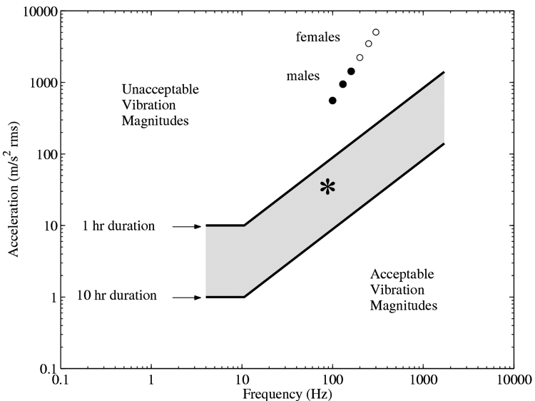
For vocal fold vibration, one of our own studies showed major disruption of epithelial cells and basement membrane structures after 2-4 hrs of continuous phonation of canine vocal folds.⁴⁸ Initially, microvillae were blunted and obliterated and then the outer layers of epithelial cells were desquamated. Some of the extracellular matrix was shed in the final stages of exposure to vocal fold collision. In other trauma-related voice disorders, e.g. vocal nodules, the basement membrane attachment to the lamina propria weakens and fluid fills the space. Reinke’s edema is a vocal fold disorder in which large amounts of fluid accumulate along the entire length in the superficial layer of the vocal fold lamina propria.⁴⁹
Figure 5. Maximum allowable tissue acceleration for hand transmitted vibration and for vocalization
A considerable body of literature exists for disorders related to excessive vibration of the hands through the skin. Studies have shown that arteries change their extracellular matrix around the arterial wall (intimal thickening) after exposure to hand-transmitted vibration.⁵⁰ The responsiveness of arterial smooth muscle to noradrenalin was greatly increased and vasoconstrictive activity of noradrenalin was raised during excessive vibration to the hands, which causes “white finger”.⁵¹ Murfee et al. found that the number of capillaries was reduced in muscle tissue after exposure to vibration (45 Hz avg., 30 – 90 Hz range).⁵² Blood vessels are sensitive to vibration, probably because rupture can easily occur if vibrational stress shears the wall.
Figure 5 shows the relation between maximum allowable tissue acceleration at various frequencies and durations for hand-transmitted vibration.⁵³ The gray bar in the middle represents the boundary between acceptable and non-acceptable vibration magnitudes and frequencies. This boundary shifts up and down depending on duration of exposure. A one hour exposure at 10 Hz and 10 m/s² has the same effect as a 10 hrs exposure at 10 Hz and 1 m/s². The data points labeled males and females in the upper part of Figure 5 are for amplitudes and frequencies typical in vocal fold vibration (our own calculations). Note that 1 hour of continuous vibration (let alone 10 hrs) is clearly unacceptable. Of course, vocal fold vibration is never continuous for more than a few seconds. Hence, short-term recovery is an important factor, which can be addressed with bioreactor technology.
In some cases, vibration can first be beneficial and then detrimental. Exposure of nerves to vibration at 80 Hz frequency and 30 m/s² acceleration (see asterisk in Figure 5) daily over 2 – 5 days first induced a significant increase in the outgrowth length of axons in the hind limb of rats.⁵⁴ The investigators concluded that these axonal changes may be purely local, but could also be a response of the neural cell bodies in the dorsal root ganglion. By putting the axon into mechanical vibration, the regenerative potential of the neuron is likely to increase. But the exposure lasted five hours daily, which according to Figure 5, was a bit excessive. If the vibrational stress on the axon is too large and too close to the cell body, the neuron will die.⁵⁵⁻⁵⁷

Beneficial Effects of Vibration Exposure
Contrary to the damaging effects of vibration, exercise physiology and sports medicine have recently brought into discussion the topic of vibration training, at least for muscle tissue. The basic concept is that dumbbells, barbells, and other weight training instruments should not only expose muscles to a resistive force, but also to vibration. It is hypothesized that, because vibration produces vasoconstriction, the deprivation of blood circulation will open up new capillaries to compensate for the loss of circulation in the existing ones. The result would be a more efficient metabolism in the muscles, according to the hypothesis.⁵⁸ LaMothe and Zernicke found that rest periods combined with vibration (about 30 Hz) alternating with mechanical loading was more effective in building muscle and bone tissue than mechanical loading by itself.⁵⁹
Regeneration of bone tissue has been shown to be affected by exposure to a frequency spectrum up to 40 Hz. Twenty-minute bursts of 30 Hz vibration per day over five days increased the density of bone in the proximal femur of an adult sheep by 34%. Interestingly, the strain levels were three orders of magnitude lower than those that damage bone tissue.⁶⁰ Thus, the beneficial effects of vibration in tissue growth can be realized with small dosages.
At the molecular level, sister chromatid exchanges, which represent a symmetrical exchange of chromatid segments within a single chromosome, generally do not affect the overall construct of the chromosome. The exchanges occur regularly and naturally. DNA analysis of the exchanges is one of the most widely used methods for detecting exposure to genotoxic agents.⁶¹ Exposure to whole-body or hand-transmitted vibration may contribute to an increase in the level of sister chromatid exchanges in humans.⁶²
A neuropharmacological effect of vibration on the dorsal root ganglion has been found on an animal model (rabbit). Low frequency vibration (3.5 – 5.0 Hz) of the lumbar region of the spine caused an increase in vasoactive intestinal peptide, which is known to affect bone mineralization.⁶³ The vibration also showed a decrease in substance P, a known pain mediator.^{64, 65} Quantitative changes in neuropeptides have been linked to vibration of tissues.⁶⁶ Additionally, more frequent occurrences of higher glucose and serum insulin concentrations were found in persons exposed to low and medium frequency whole-body vibration.⁶⁶

Review of Issues Related to Bioreactor Design
At a recent meeting, Freed at al. described a variety of issues relating to tissue engineering within bioreactors. Issues discussed at this meeting included the use of scaffolds and bioreactors as tools in tissue regeneration research, the need to quantify and learn about mechanical forces applied to tissue constructs within bioreactors, and the need to engineer tissue in a biomimetic environment.⁶⁷ Bioreactor systems are the tools often used for in vitro experimentation with engineered tissue. According to Freed & Vunjak-Novakovic, bioreactor systems should provide: 1) spatially uniform cell distributions on three dimensional scaffolds; 2) gas and nutrient concentration maintenance (and exchange); 3) efficient mass transfer to growing tissue; and 4) physical stimulation of developing tissues.⁶⁸
Obradovic et al. studied the effect of gas and nutrient exchange rates on cell metabolism and tissue composition of engineered cartilage.⁶⁹ They used rotating bioreactor systems and subjected tissues to varied conditions of nutrient and gas exchange. Cellular metabolism was measured by yield ratio of lactate to glucose (Y_{L/G}), and was related to pH and oxygen tension (pO₂). High pH (~7.0) and high pO₂ (~80 mm Hg) were associated with aerobic cellular metabolism (Y_{L/G}=1.65-1.79 mol/mol), while low pH (~6.7) and low pO₂ (~40 mm Hg) were associated with anaerobic cellular metabolism (Y_{L/G}=2.2 mol/mol). Results indicated that infrequent gas exchange (defined as three times per week for 5 h) was successful in maintaining aerobic cellular metabolism, and resulted in larger constructs (152 mg/construct wet weight compared to 101 mg/construct wet weight in the no gas exchange condition) with higher amounts of glycosaminoglycan (GAG) (4.55% wet weight compared to 3.07% wet weight in the no gas exchange condition). GAG is a particularly useful molecule for measurement of the quality of engineered cartilage. In vocal fold tissues, one type of GAG has been described, hyaluronan (HA), which is a nonantigenic GAG polysaccharide.⁷⁰ It is believed to provide lubrication to the vocal folds and to keep viscosity within a reasonable range for phonation.⁷¹ Uniform spacing of GAG throughout a tissue construct is beneficial and is often achieved by subjecting the tissue to mechanical stimuli.⁶⁸
Force application to tissues is part of any bioreactor design. Structure and function of tissues are affected by the presence or absence of forces. Bone cells generate different levels of activation chemicals when vibrated than when not vibrated.⁷² Cartilage tissue growth and its elastic modulus doubles when grown in gravity rather than no gravity.⁷³ Cardiovascular tissues grown in dynamic flow similar to aorta flow develop into a multilayered system in 28 days with three times the strength than tissues grown without dynamic flow.⁷⁴ As another example, endothelial cell movement and cellular pathways vary depending on the frequency, duration and amplitude of direct stimulation using a micro-bead.⁴¹ In applications to voice, hearing and skin tissue vibration, the goal is therefore not only to stimulate tissue growth but to quantify vibrational stresses and to measure the altered properties. This has been attempted in very few bioreactors.^{72, 75} Bacabac and colleagues determined regions of quasi-steady-state dynamic flow in a parallel plate flow bioreactor but the bioreactor was limited to 5 – 30 Hz vibrations.⁷² Tanaka used a compression bioreactor that delivered 1 second periodic compression, white noise compression of 0 – 50 Hz, or a combination of the two at 3000 and 300 µstrain, respectively. Responding movement of the osteoblast seeded collagen, however, was not reported.⁷⁵
To our knowledge, the first bioreactor approaching physiologic conditions for speaking, hearing, and skin vibrations was spearheaded by Titze and colleagues.^{76, 77} It was the launching pad for the current work and is described in the preliminary studies section.

Significance
The significance of the proposed research is the extension of bioreactor design into the difficult region of sonic frequency force fields. To our knowledge, this has not been attempted in a systematic way. We acknowledge that application is to a limited range of tissues types and organs, but given the accumulation of information that exists about healthy and unhealthy vibration exposure to body tissues in general, future applications may go beyond current expectations. For our immediate application to larynx, ear, and skin tissues, it should be mentioned that 28 million Americans suffer from hearing loss, including 2% of children under 18 years of age (American Speech and Hearing Association), 11% of the nation’s 4 million teachers report voice disorders from excessive talking,^{78, 79} and 93,000 injuries are due to repetitive motion exposure, culminating in approximately 18 days of work loss per year.⁸⁰ Some of the voice and hearing disorders will likely be treated by regenerative medicine. Constructs will be implanted or injected for repair of scar tissue, calcified or ossified tissue, chronically inflamed tissue, or tissue destroyed or altered by various diseases. We expect that some of the components of these engineered constructs will need to be tested under conditions of vibration. Efficient mechanical transduction of vibrational energy between engineered components, and the ability to withstand large doses of vibration, will always be a concern. Hence, bioreactor design, and especially the ability to do mechanical testing in the bioreactor, would appear to be a high priority.

C. PRELIMINARY STUDIES
The preliminary studies are organized according to the specific aims. Thus, section C1 pertains to Aim 1, C2 to Aim 2, etc. Significant pilot data exist for all aims.

C1. Preliminary Studies on the Geometry of Constructs in Vibrational Bioreactors (Aim 1)
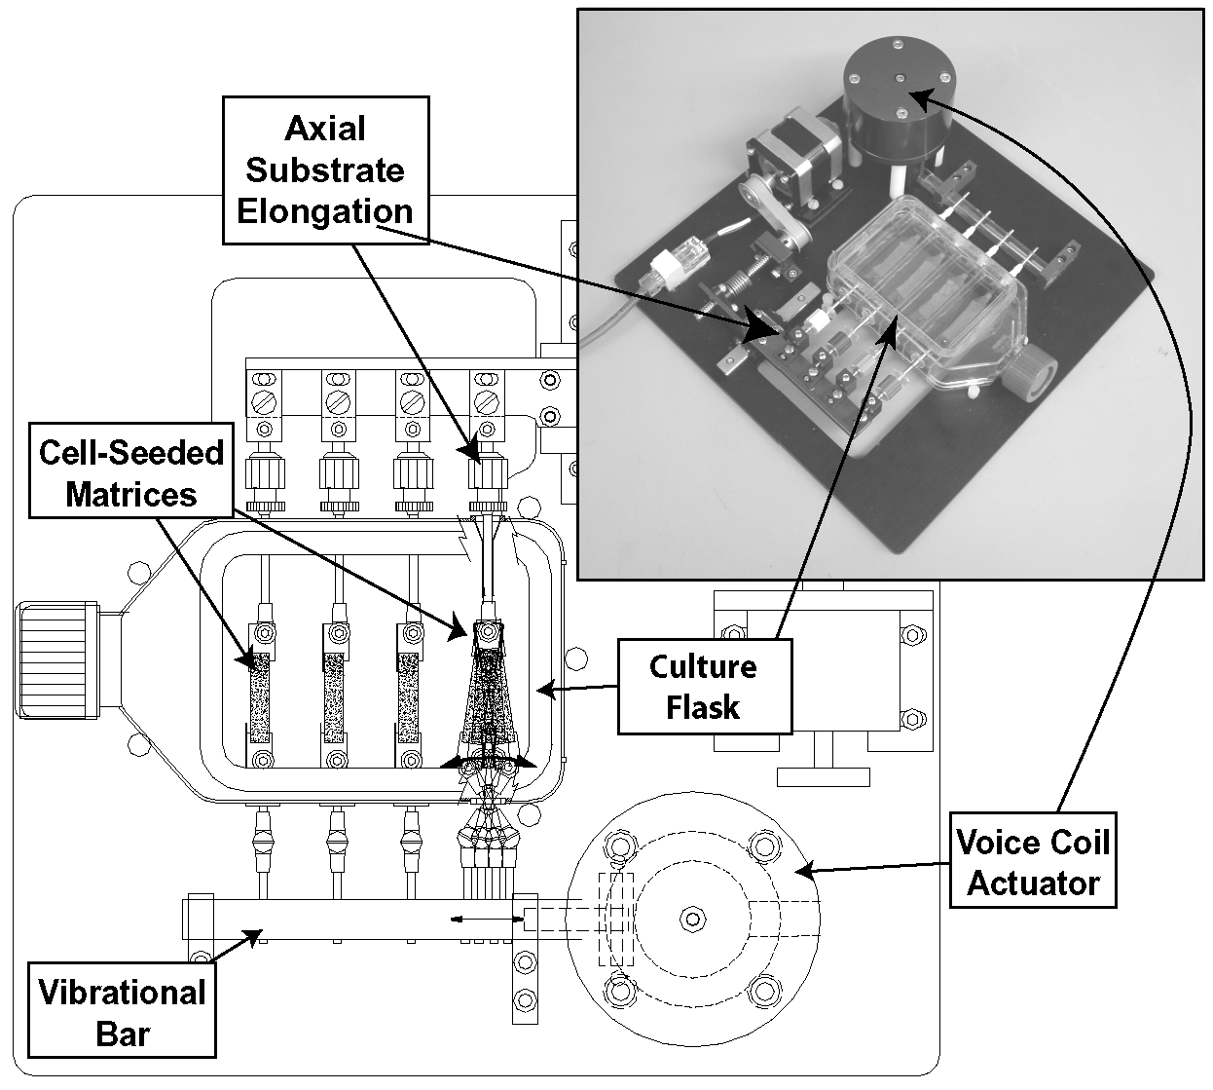
With colleagues from the Keck Tissue Engineering Center at the University of Utah (a group led by Patrick Tresco, Ph.D.), our first bioreactor was designed to simulate the vibrational stresses in viable tissues at low sonic frequencies. The design was primarily for elastic constructs that can be deformed uniaxially, like a ribbon, fiber bundle, or string.
Figure 6. The first bioreactor simulating vocalization-like vibrations (collaboration between the University of Utah led by Patrick Tresco and National Center for Voice and Speech led by Ingo Titze)
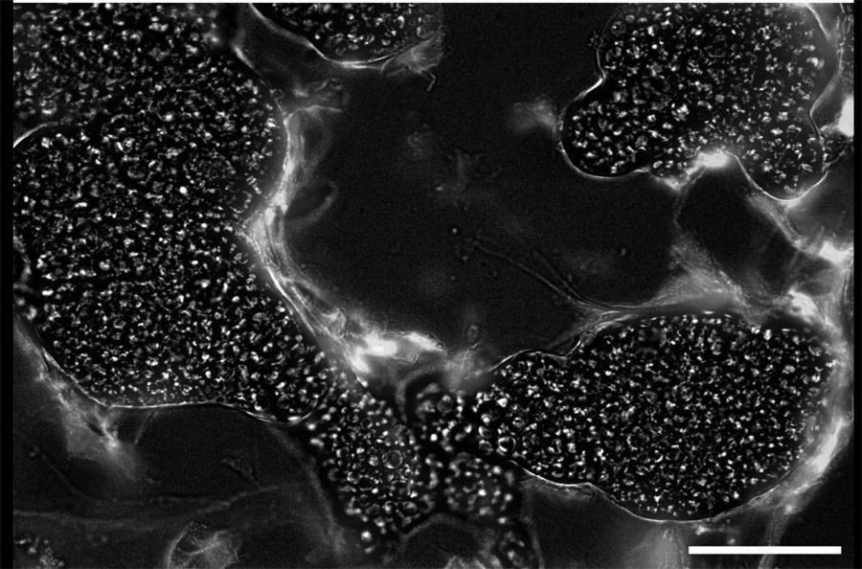
Intended applications were for a bundle of muscle fibers or a vocal fold ligament, but could eventually be extended to a tympanic membrane or cochlear tissues. For these ribbon-like constructs, initial requirements were 0 – 1 mm transverse amplitudes in the 20 – 200 Hz frequency range, a variable on-off stress regime, and maintenance of tissue viability over several hours. One version of this bioreactor uses dual drivers (Figure 6), one for axial substrate elongation and one for vibration (voice coil actuator). In this design, there are four engineered tissues inside a T-flask (labeled cell-seeded matrices) with driving attachments penetrating the walls. On top is the servo-controlled driver for low frequency axial strain (< 5 Hz), and on the bottom is the voice coil actuator for high-frequency (up to 200 Hz) transverse movement. Human vocal fold fibroblasts were seeded in the strip-like matrices (polyurethane substrates) and subjected to elongation and vibrational forces (Figure 7).⁷⁶ In one experiment, the constructs were axially strained by 20% while a 100 Hz vibratory displacement was applied simultaneously. Mechanical stimuli were maintained for 6 hrs continuously, and cells maintained viability as demonstrated by immunohistological analysis (Figure 7).⁷⁶
Figure 7. Viable cells (white and gray clouds) in a polyurethane scaffold (white stipples on black) after 6 hrs of vibration. (Scale bar =40 µm)
Changes in mRNA expression levels of several ECM-related genes normally expressed in the human vocal fold were also examined in response to two conditions: (1) constant 20% axial strain and no vibration and (2) constant 20% axial strain and 100 Hz vibrational strain. The quantity of RNA was determined by A₂₆₀ and the quality verified by gel electrophoresis. Figs. 8a and b show changes in the mRNA expression levels of various matrix-associated genes. Values are expressed relative to static controls (labeled as 100%). We found that a 20% axial strain significantly increased expression of the matrix protein message for elastin, alpha 1(I) procollagen, and fibronectin relative to the 100% static control level (Fig. 8a, light gray bars). The addition of a 100 Hz vibratory component (dark bars) further increased expression levels of message for fibronectin, MMP-1, HA synthase 2, and CD44. The addition of vibratory stimuli also produced a small increase in expression of fibromodulin and decorin relative to samples exposed to axial strain alone. Expression for hyaluronidase was unremarkable for either stress regime.
Figure 8. mRNA gene expression for 20% strain alone, and 20% strain plus vibration, each for 6 h
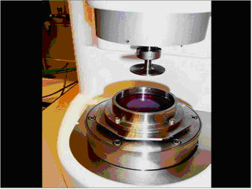
A limitation of our first bioreactor was a relatively low strain at the high frequencies. Resulting strain maxima, as determined through analytical calculations of standing waves of the ribbon, were 0.1 – 0.2 up to 70 Hz but only 0.05 at 130 Hz, with a declining strain gradient along the length of the ribbon.⁷⁷ For cochlear tissues, position-dependent strain along the construct represents normal function, but for vocal fold tissues, higher strains at higher frequencies (100 – 1000 Hz) are desirable. A greater short-coming of the first bioreactor was its inability to directly measure mechanical properties of the tissues in the bioreactor.
Figure 9. Cell seeded substrate in 2nd bioreactor, submerged in medium
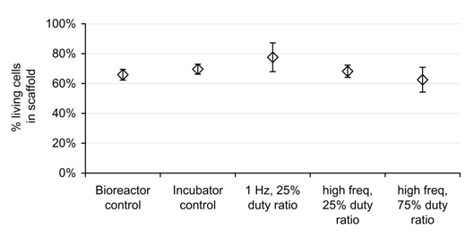
The proposed bioreactor overcomes some of these limitations. Shown in Figure 9 is what we call a rheometer-bioreactor. The basic machinery is a commercial rheometer, retro-designed to contain its own culture well and incubator. A custom designed stainless steel cup mounts directly onto the base plate of the rheometer so that upper plate and cell-seeded substrate submerge in nutrient medium. The upper plate makes contact with the substrate and is programmed to apply the desired shear stress or strain. This configuration works well for tissue disks, gels, or fluids.
Figure 10. Mean viable cell fractions (sem) after 2 hr test conditions
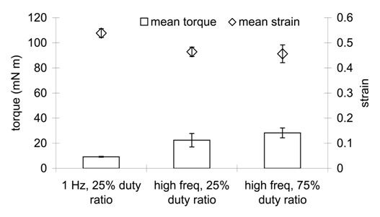
Functionality of the rheometer-bioreactor with regard to four requirements was recently demonstrated for short term experiments 2 – 6 h using a tissue disk. The requirements were (1) uniform cell distribution, (2) gas, nutrient, and fluid exchange, (3) vibrational strain quantification, and (4) rheologic measurements in the rheometer-bioreactor.⁸¹ The first requirement, to promote uniform cell distribution, was determined by the scaffold architecture and biocompatibility. Therefore, the same elastomeric scaffold was provided by Dr. Patrick Tresco at the Keck Tissue Engineering Center, University of Utah, and the same cell seeding protocols were followed as specified in other studies where extensive cellular analyses were performed.^{76, 82} Achievement of uniform cell distribution will be addressed for each scaffold proposed in the Methods.
Figure 11. mean applied torque and responding mean strain ±SEM (n=3) of fibroblast-seeded TFX scaffold for three vibration conditions: 1 Hz and 25% duty ratio, 60 Hz and 25% duty ratio, and 60-70 Hz 75% duty ratio
Second, adequate gas, nutrient, and fluid exchange, were evaluated for up to 6 h. We found that for this short time period, cell viability was maintained at 60 - 80% (Figure 10), and environmental pH, osmolality and change in osmolality were in an acceptable range when using 22 mM Hepes buffer in the nutrient-rich liquid media.⁸¹ For longer incubation times, additional modifications and environmental measures will be implemented as described in the Methods.
Third, vibration was quantified during tissue stimulation. Applied torque and resulting strains were recorded 30 – 40 times throughout a 2 h vibration experiment, large strains of 0.4 – 0.5 were achieved, and only a fraction of the machine’s available torque (120 mN m) was used (Figure 11). As we aim to triple the large amplitude driving frequency (up to 250 Hz), which is above the coupled system resonant frequency in the Klemuk & Titze study,⁸¹ there will be sufficient torque to achieve strains of 0.1 – 0.5.
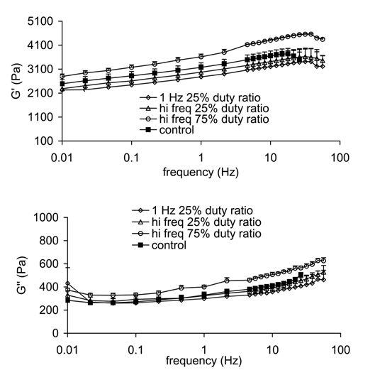
Finally, the fourth requirement, to take rheologic measurements of an tissue engineered disk in the rheometer-bioreactor, was satisfied.⁸¹ Viscoelastic measures were obtained on living tissues while in the rheometer-bioreactor before and after vibration experiments (Figure 12). Shear elastic modulus is symbolized by G’ and shear viscous modulus is G’’. Values were in the range of vocal fold related biomaterial properties, and they were in the range of unseeded substrate properties in the frequency range tested (0.01 – 70 Hz).^{9, 81, 83} Factors that will determine measurement accuracy include maximizing the plate and sample radius, minimizing the gap between the plates in a parallel plate system, controlling the instrument for temperature, maintaining concentricity, parallelism of the plates, the empirically determining the motor inertia value, correcting for phase error in the transfer function between applied torque and resulting plate rotation, satisfying gap loading and linear viscoelastic conditions, reducing sample drying and slippage, and accounting for sample compression.^{81, 84-89} Our research team has developed and implemented protocols to account for these sources of measurement error.^{83-85, 90-92} Methodologies that include the above considerations will be developed for each material type discussed in this grant proposal.
Figure 12. Mean elastic moduli (G’) (top) and mean viscous moduli (G’’) (bottom) of fibroblast-seeded TFX substrates after exposure to various vibration regimes. Error bars represent one standard error
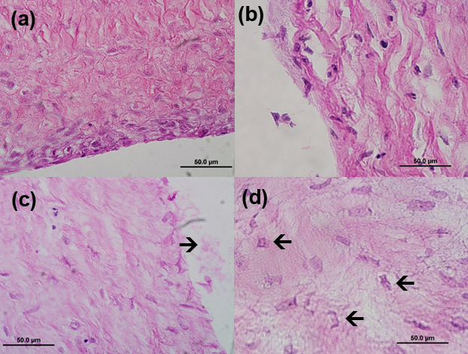
Another construct we tested in the rheometer bioreactor is a dermal fibroblast seeded extracellular matrix disk (100 μm thick, with a diameter of 75 mm). It is known as a “dermal equivalent” and was obtained through collaboration with Organogenesis (Canton, MA). Prior to shipping, each dermal equivalent was grown in culture medium in a removable trans-well within a custom-made Petri dish. Oscillatory shear strain deformation of the tissue was administered in our laboratory with the rheometer-bioreactor. Extreme vibration conditions were tested. The minimal condition was a strain of 0.01 at 10 Hz, and the maximal condition was a strain of 0.6 strain 100 Hz. Strain was turned on and off every 10 s for one h.
Figure 13. H & E staining of dermal construct for (a) control, (b), 10 Hz vibration, and (c)-(d) 100 Hz vibration (60X magnification, black bar=50μm)
Rheological properties of two samples were measured in the rheometer-bioreactor prior to vibration exposure at frequencies up to 50 Hz. The elastic modulus G’ was 500-900 Pa and the viscous modulus G’’ was ~200Pa at 30 Hz. These moduli were nearly level across frequency, with the ratio of G’’ to G’ being 0.2 – 0.5. But the variation in G’ values indicated lack of mechanical adhesion between the hard plate surfaces and the construct. Addition studies will be conducted to ascertain the degree of slippage and to reduce slippage by treating hard surfaces.
Following the vibration exposure, samples remained intact. They were fixed in zinc formalin, frozen sectioned, stained with hematoxylin and eosin, and imaged. Figures 13a-13d show cross-sectional views at 60X magnification of (a) the control, (b) the 10 Hz vibration dose, and (c)-(d) the 100 Hz vibration dose.
(a)
(b)
(c)
(d)
The dermal constructs did not change much in their gross structure when exposed to low strain and frequency as compared to the control. The tissue had a wavy, loosely packed appearance with cell nuclei spread throughout. But when the tissue was exposed to oscillatory high strain, the tissue edge (at the plate edge, where the displacement is largest) appeared tattered (compare Figure 13c at arrow with 13a). Also, the cell nuclei were no longer oblong but more rectangular (or box-like) in shape, as seen in Figure 13d (see arrows).
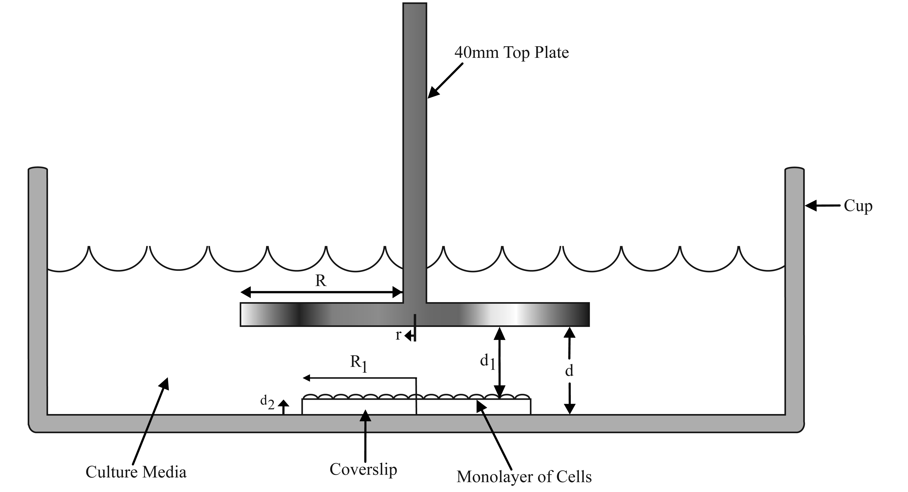
Another geometric construct we explored in preliminary studies is a thin film, or monolayer of cells. We developed the experimental set-up for exposing monolayers to either the combination of shear stresses and inertial stresses, or shear stresses alone (Figure 14). By attaching a cell-seeded coverslip to either the top rotating plate or to the stationary base, the rheometer-bioreactor has the unique capacity to couple or decouple the two forces. Vocal fold fibroblast cells (VFFCs) were isolated from human larynges. Glass cover slips, with a hole drilled in the center, were seeded with the cells and incubated for approximately 18-22 hours. The coverslip was then attached to either the rotating plate or the stationary base using a small set screw and washers. Vibration was exerted in the bioreactor by immersing the cover slip in cell culture medium augmented with methyl cellulose (to increase fluid viscosity). Methyl cellulose has been shown to prevent human skin fibroblast cells from losing their adhesive properties⁹³ and cells have been known to respond positively to solutions up to a 2% methyl cellulose solution.⁹⁴⁻⁹⁶. Stresses up to 2000 Pa and frequencies up to 100 Hz were programmed for stress exposure to the cell monolayer for 2 h. H & E (hematoxylin & eosin) was used to stain the cells after exposure to mechanical stress. Phase contrast observations of cell morphology were made using a light microscope. Cells maintained morphology and were elongated with no apparent orientation. The exception was for a 100 Pa steady shear (continuous rotation rather than oscillation) where cells detached from the coverslip. It is yet unclear what the exact stresses on the cells were. Because the moving plate was not in direct contact with the monolayer surface, stresses were transferred through the cell culture medium. A linear stress variation in the gap was assumed, but a boundary layer may exist. This requires further investigation. Also, the coverslip was considerably smaller than the oscillating plate, 9 mm radius as compared to a 22.4 mm radius. Extensive product searching led to this 9 mm glass coverslip as the only alternative, so the mismatch between the coverslip radius and the larger plate radius was unavoidable. Future investigations will correct this mismatch by using highly translucent plastic coverslips.
Figure 14. Schematic of non-inertial monolayer setup
A thin film or monolayer is ideal for studying adhesion properties of cells. A previous study on vocal folds showed epithelial cell separation at the basement membrane, indicating that there is an adhesion limit after which significant tissue destruction occurs.⁴⁸ The same may be true for dermal tissues. We have not yet found the exact stress limits of cell adhesion on fibronectin-coated surfaces, but preliminary results indicate about 4000 Pa. We will therefore address these questions in the Methods to extend application of thin film constructs in the rheometer-bioreactor to vocal fold and dermal cells.
These preliminary studies have demonstrated some experience in working with different geometries, revealing both strengths and weaknesses in bioreactor systems. The proposed rheometer-bioreactor will be further developed to apply shear strains to construct geometries including viscoelastic disks, ribbons, gels, fluids, and thin films. The rheometer-bioreactor’s current design is equipped to administer simple shear to isotropic materials. Examples of such materials are the superficial and intermediate layers of the vocal fold lamina propria, perilymph or endolymph cochlear fluids, dermal membranes, and thin films containing a cell monolayer. We will extend the function to non-isotropic materials by designing and building appropriate appliances.

C2. Preliminary Studies on Vibration Dose and Translation to Bioreactor Function (Aim 2)
To quantify the self-induced vibration exposure in vocal fold tissues by humans during speech production, vocal doses were defined and described in a five-year funded project. One was a distance dose, which accumulates the distance that tissue particles of the vocal folds travel in an oscillatory trajectory. Another was an energy dissipation dose, which accumulates the total amount of heat dissipated over a unit volume of vocal fold tissues. Measurements of vocal fold viscosity were used to calculate the doses on human volunteers from the fundamental frequency (F₀) and sound pressure level (SPL) of their speech. Six participants were asked to read in normal, monotone, and exaggerated speech.
The vibration exposure of vocal folds was related to the industrial limits for hand-transmitted vibration (Figure 5, described earlier, the only standard available), from which the safe distance dose was derived to be about 500 m. This limit appeared to be rather restrictive for vocalization; it was comparable to about 17 min of continuous vocalization, or about 35 min of continuous speaking with normal breathing and unvoiced segments. The voicing pauses in normal speech and the longer rest periods in dialogue effectively prolong the safe time dose,⁹⁷ but we don’t know how much.
The derived safety limits for vocalization will require refinements based on a more detailed knowledge of the differences between hand tissues and vocal fold tissues and their response to vibrational stress, and on the effect of recovery of the vocal fold tissue during voicing pauses. This is exactly why a bioreactor is needed. A regime of exposure can be programmed to match existing conditions in human behavior. For example, the National Center for Voice and Speech (NCVS) data bank on voice dosimetry can be used for this modeling. In this data bank, the distributions of continuous voicing periods and silence periods in 31 teachers were gathered over the duration of two weeks. Recordings were made during all awake hours of the day. Voicing periods were grouped into half decades, ranging from 0.03 - 0.10 s for the shortest periods of phonation to 30 - 100 s for the longest periods of phonation. Silence periods were grouped into similar half decades, but ranged up to several hours. On average, the teachers had 1800 occurrences of voicing (onset followed by offset) per hour at work and 1200 occurrences per hour while not at work. Voicing occurred 23% of the total time at work, dropping to 13% during off-work hours and 12% on weekends. The greatest accumulation of voicing occurred in the 0.3-1.0 s voicing periods, whereas the greatest accumulation of silence occurred in the 3.0 - 10 s silence periods. The study begins to lay the groundwork for understanding fatigue of transduction tissue in terms of cyclic motion and collision, as well as recovery from such mechanical fatigue.⁹⁸
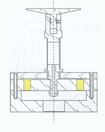
Preliminary dose exposures to living tissues have already been administered in our bioreactors. Strains of 0.01 – 0.6, frequencies of 0.01 – 100 Hz, duty ratios of 0.25 – 1.0, durations of 20s, 30 min, and 6 h, and total accumulated times of 2 – 6 h have all been implemented. There is, therefore, much promise that the rheometer-bioreactor can mimic human phonation episodes, but there are many tasks yet to be completed before it can be used over many days. The core machine is a commercially built Gemini 150 rotational shear rheometer outfitted with a standard inductive Rotonetic™ torsional motor. It is manufactured by Malvern Instruments (Worcestershire, UK). The inductive torque motor operates at low frequencies, 1*10⁻⁶ – 150 Hz, for vibration experiments and for rheological measurement. Whether stress or strain is controlled depends on the physiologic condition to be simulated. As a voice use example, assume that a school teacher must maintain vocal intensity for long durations. Vocal fold vibrational amplitude (i.e., strain) may then be regulated. As a hearing example, a person attending a rock concert would experience sound pressure levels controlled by the rock band (i.e., stress). Middle and inner ear tissue displacement (i.e., strain) is then a dependent variable. The important point is that the rheometer-bioreactor can function in either mode, allowing for flexibility in answering a variety of scientific inquiries.
Figure 15. Schematic of piezo rotational vibrator
All electronics are integrated with a digital signal processor and Windows OS software. We have recorded all raw torque values and position sensor information during vibration and during measurement, made possible by collaborations with senior staff at Malvern Instruments. We have already written code to Fourier transform the data, calculate G’ and G’’ values, and then compare them to Malvern software results.^{81, 85, 90} However, extensive programming is still required to operate vibration doses lasting hours to days and to extend stimulation frequencies up to 250 Hz. Discussions with, and letters of support from Malvern Instruments product managers are indicative of their interest in our preliminary studies and their enthusiasm for providing “expert advice on operational modifications”.
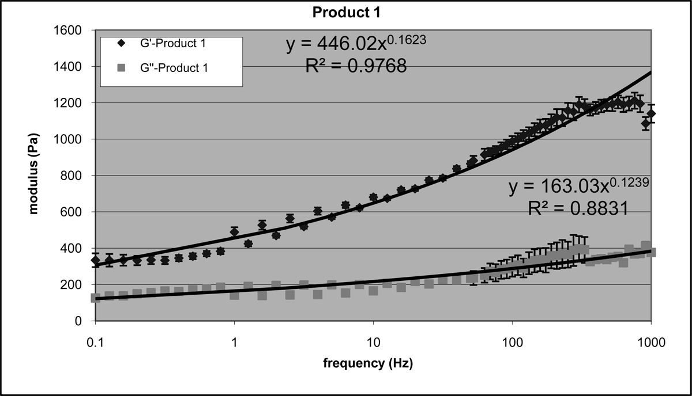
A piezoelectric rotational vibrator (PRV) (Malvern Instruments) is an attachment to the Gemini and has proven to generate accurate rheologic data up to 2000 Hz (Figure 15). It consists of six piezo elements arranged in a circle. Three of the elements are excited by a Lock-In amplifier and the other three detect angular deflection. Frequency continuity is maintained, because both the Gemini and the PRV can generate data in the same 1 – 100 Hz frequency range. This continuity in the overlap region has already been shown.⁹⁹ Our own data show excellent overlap across frequency for a carbomer hydrogel (Figure 16). The piezoelectric rotational vibrator (PRV) can also be used for vibration experiments at deflections of nanometers up to 100 µm with frequencies up to 5000 Hz (as per personal communication with Malvern experts), allowing for vibrations pertinent to ear tissues. The PRV mounts to the base of the Gemini rotational rheometer, replacing the stationary, temperature controlled Peltier base. A parallel plate or a cup (specially made for our applications) is a PRV shaft extension. Samples are prepared as if the base were stationary. The only difference is that the upper torque motor must be locked when the PRV is operational. Conversely, the PRV must be locked when the Gemini motor is operational.
Figure 16. Mean G’ and G’’ (SEM) values of a carbomer hydrogel collected with the Gemini 150 (0.1 – 50 Hz) and the PRV (1 – 1000 Hz). Values from both machines were averaged together in the 1 – 50 Hz range
Tissue construct adhesion to the plates is important for stress application and accurate measurement.⁸⁵ Sufficient van der Waals forces or frictional forces are usually generated between the stationary cup base and engineered construct. When this occurs, uniform deformation of engineered constructs is generated without affecting the structural, molecular, or cellular composition of the construct. However, for some materials, surface roughness of the metal plate and cup that comes in contact with the sample is needed. We have already implemented the use of roughened surfaces for improved measurements of animal tissues and biomaterials,^{81, 83, 85, 86, 90-92, 100} and we will continue to dedicate experiments to this topic for satisfactory long-term adhesion.
Most biomaterials used for tissue engineering are porous, in which case viscoelastic properties will be affected by compression. Order of magnitude viscoelastic changes of polyurethane, as a function of sample compression have been reported,⁸¹ but compression is often necessary for porous materials in order to improve adhesion. We recognize this potential complication with accurate and reproducible vibration delivery and measurement. It will be addressed in the proposed methods.

C3. Preliminary Studies on Bioreactor Environment (Aim 3)
Short term (0 – 6 h) rheometer-bioreactor environmental studies have been conducted by our research group. The rheometer-bioreactor presents unique challenges, because it cannot easily be placed in a sealed incubator. The rheometer itself is approximately 50 cm tall, 30 cm wide, and 30 cm deep. It has purified air lines, water lines, and digital cables connected to peripheral devices. It cannot be moved without performing extensive calibrations. Additionally, the user needs to have access to stationary and moving parts for mounting, dismounting, raising, and lowering the rotating plate. Given that dry air is used for reduction of bearing friction, we found that evaporation of the cell nutrient medium was a considerable challenge.⁸⁴ Up to 22% of cell nutrient medium evaporated in 3 h and about 50% evaporated in 8 h with most fibroblasts not remaining viable. The environment was improved by including 1.5mM of Hepes buffer in the medium as indicated by cell viability, but pH remained high.
Next, we studied the evaporation problem by using a specially designed acrylic lid covering the rheometer-bioreactor cup. Deficiency in CO₂, humid and non-humid environments, and sterility were addressed. The concentration of Hepes (N-2-hydroxyethylpiperazine-N’-2-ethenesulphonic acid) varied 0 – 82 mM. Hepes is a widely used organic buffer that is resistant to rapid pH changes and is effective in the pH range 7.2-7.6. Measurements included cell viability (using trypan dye exclusion), pH, and osmolality. The latter two measures were chosen because excessive changes in them (possibly due to medium evaporation in our rheometer-bioreactor), can lead to cell trauma. From our own study, a pH value of 8.69 resulted in cell death.⁸⁴ Osmolality is the ratio of moles of solute to kg of solvent. In one study from another laboratory, increased osmolality evaluated at 320-476 mOsm/kg decreased hybridoma cell proliferation rates and increased apoptotic cell death.¹⁰¹ In another study, changes greater than 50 mOsm/day resulted in neural cell culture death.¹⁰²
In combination, we found that Hepes concentrations of 4.5 – 22 mM, pH values at 7.1 – 7.5, and osmolalities at 310 – 340 mOsm/kg kept fibroblast viability at 73 – 81%. This is an acceptable viability for many applications. Cell contamination was ruled out as a possible cause for cell death for two reasons. First, all cell culture media contained gentimicin and fungizone to deter bacterial and fungus growth. Second, cell viability under a non-sterile condition (waterbath) was higher than in a sterile condition (laminar flow hood).⁸¹ Hence, we concluded that contamination was prevented for experiments under 4 h. Osmolality change was 20 mOsm/kg or less in a 4 h test. Although osmolality change exceeded recommendations for neural cells, fibroblasts were in an acceptable range as long as experimentation did not exceed 4 h. As vibration dose experiments extend to several days, we will need to design and build a custom chamber to surround the rheometer bioreactor, incorporate an active humidification system, automated CO₂ delivery, and extend environmental testing to include previous measures as well as CO₂ levels, oxygen tension and cell metabolism measures.

C4. Preliminary Studies on Viscoelastic Wave Excitation in Engineered Tissues (Aim 4)
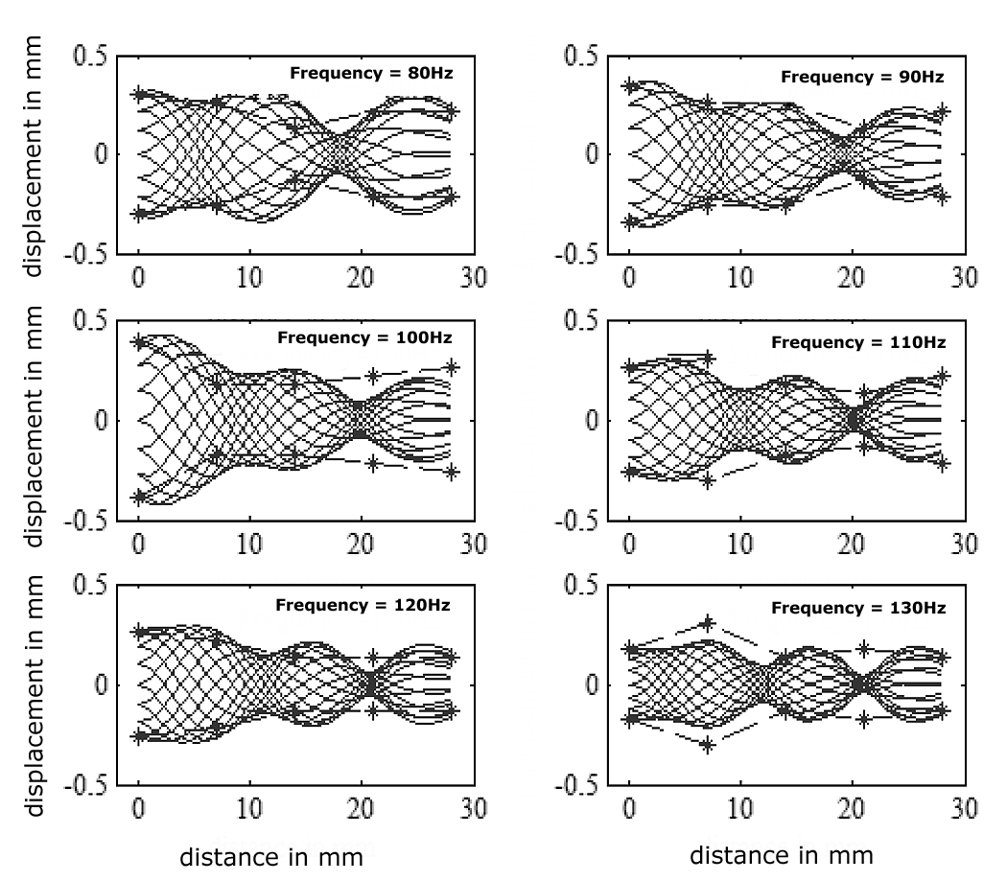
Our first bioreactor (with the Utah group) was used to quantify stresses and strains along a bioengineered ribbon-like construct, with dimensions similar to a vocal ligament or a basilar membrane of a larger mammal. The construct was driven at low sonic frequencies (20-200 Hz). Standing wave patterns (Figure 17) were calculated analytically by solving a classical boundary value problem for a vibrating string under tension and bending stiffness.
Figure 17. Analytically calculated standing waves for a vibrating string and experimental measures (stars)
Boundary conditions were non-traditional in that small pivot arms at the endpoints allowed neither the displacement nor the velocity to go to zero. The calculations were corroborated with stroboscopic measurement of the motion of the material in the bioreactor (asterisks in Figure 17). Vibrational nodes and antinodes appeared, although the spatial sampling was coarse, and shear strains up to 0.2 occurred in the strain antinodes at low frequencies (20 Hz), with a gradual decrease at higher frequencies due to the decaying amplitude response of the mechanical driver. For vocal fold tissues, a yet unsolved problem is a variable drag coefficient along the length of the material due to fluid turbulence in the culture medium.⁷⁶ But this fluid drag is less of a problem for cochlear mechanics because it simulates true physiologic conditions. Fluid always surrounds the membrane and vibrational amplitudes are small enough to prevent fluid turbulence. We believe, therefore, that this pilot study lays the groundwork for studying wave motion in cochlear tissues in a bioreactor. The viscoelastic properties of perilymph and endolymph can first be determined separately and then simulated in the culture medium. The first challenge, however, is to increase the frequency range of the bioreactor with the piezoelectric appliance.
D. METHODS
Methods are organized in the order of the specific aims. We will develop three to five rheometer-bioreactors with the same design and environmental conditions, three of which can be made operational with existing instrumentation. Control tissue samples and experimental samples will be tested simultaneously, each in its own bioreactor.

D1. Extending Vibration Delivery and Rheologic Testing Machinery to Varied Tissue Geometries (Aim 1)
Versatility of our bioreactor will be tested using 5 different geometries: disk, ribbon, gel, fluid, and film. Each geometry can be made from more than one material. Geometries will correspond to laryngeal, ear, or skin tissues, will be biologically or synthetically derived, and will have a range of viscoelastic properties. Table 1 categorizes example constructs or tissues corresponding to the different organs and geometries.

Table 1. Possible tissue constructs, described in terms of geometry and organ
Geometry | Organ
Geometry | Larynx | Ear | Skin
Disk | 2,3-DAC cellulose constructs | Tympanic membrane | Dermal patch constructs
Ribbon | Acellular bovine vocal fold constructs | Tympanic or Cochlear membranes | Dermal strip constructs
Gel | Extracel™ | Extracel™ | Extracel™
Fluid | Surface mucus | Perilymph | Subdermal edema
Film | Monolayer of vocal fold fibroblast or epithelial cells |  | Monolayer of dermal fibroblast cells

Experiments D1.1 Disks Vocal fold disk geometries will be made from 2,3-dialdehyde cellulose membranes fabricated in Dr. Vijay Kumar’s laboratory in the Division of Pharmaceutics of the College of Pharmacy at The University of Iowa. Procedures include a salt leaching method followed by oxidation, dehydration and sterilization, and a gas foaming method followed by dehydration and sterilization.^{91, 103, 104}
The salt leached membranes will have 3-4% degree of oxidation (validated by the amount of metaperiodate consumption using spectrophotometry), with rheologic stability up to 42 days, 88-90% porosity (validated using a helium ultrapycnometer [Quantachrome micropycnometer-2, Quantachrome Corporation, Boyton Beach, FL]), with pore sizes larger than 10 µm, and G’ and G’’ values of 20-50 kPa and 2-7 kPa respectively across frequency (validated with the Bohlin Gemini stress controlled rheometer and the Malvern piezoelectric rotational vibrator (PRV)). The gas foam membranes will have 3 – 4% degree of oxidation, with rheologic stability up to 56 days, 95 – 96% porosity, pore sizes larger than 10 µm, and rheologic properties of 5 – 13 kPa and 0.2 – 0.5 kPa for G’ and G’’ respectively across frequency. These viscoelastic properties are comparable to vocal fold mucosa. Upon time of use, membranes will be rehydrated for 1-2 hrs, cut into either disks or strips for bioreactor experiments and seeded with vocal fold fibroblast cells (VFFCs). Cell distribution will be evaluated using confocal microscopy (Central Microscopy Research Facility at The University of Iowa). Uniform distribution is likely, because fibroblast volume is 10 times less than the pore size (0.14 – 0.92 µm³).¹⁰⁵ If cells are not uniformly distributed, seeding protocols will be adjusted. Examples are fibronectin coating and quantity and location of cell aliquots. All results will be documented with ramifications and future directions discussed.
Ear tissue disks may or may not be viable in our initial investigations. Tympanic membrane will be harvested from either human cadavers or from swine. The temporal bone will be extracted using a Schuknecht bone saw within 48 hr of death and kept in moist conditions to prevent drying. Tympanic membrane will be removed, initially keeping the annulus intact and removing the malleus to obtain a disk of tissue. This disk is then suitable for shear vibration exposure and shear rheologic measurement across desired frequencies.
Dermal equivalent disks will be acquired from Organogenesis (Canton, MA). Organogenesis will ship disks to The University of Iowa in 75 mm diameter custom made transwells, fed with cell culture medium. The disks will be maintained in a 37°C, 5% CO₂ environment, fed with cell culture medium supplemented with fetal bovine serum, and used for vibration testing within 48 hours. Approximately 64 dermal equivalent disks, where four 30-mm diameter disks punched from each 75 mm construct, will be utilized over the course of the five year grant period. Uniform cell distribution is shown in Figure 13 (previously discussed).
Experiments D1.2 Ribbons Vocal fold ribbon geometry will be made using accellularized bovine laryngeal membranes obtained from Dr. Roger Chan in the Graduate College of Biomedical Engineering and Otolaryngology – Head and Neck Surgery at the University of Texas Southwestern Medical Center, Dallas, TX, a consultant on this grant. These membranes are decellularized using a unique saline-based osmotic gradient method.¹⁰⁶ Their dimensions work best as a membrane ribbon, measuring approximately 16 mm long, 2-3 mm wide, and 0.5 – 1 mm thick. The ribbons will have porosity of 90.49 ±4.33%. More than 60% of pores will be 10 – 100 µm, intrinsic permeability of 0.21 – 3.21 darcy (1 darcy is equivalent to a 1 cP fluid flowing at a rate of 1 cm/s under a pressure gradient of 1 atm/cm), and G’ and G’’ values of 10 – 1000 Pa.^{106, 107} Membrane ribbons will be seeded with human laryngeal cells (details in D1.3) and incubated for specific times depending on a given bioreactor experiment. Cell uniformity will be evaluated using confocal microscopy. Uniform distribution is likely because of the pore structure and permeability.
Tympanic membranes will be cut into ribbon strips, keeping annulus tissue on either end.¹⁵ Using a new cup design (Experiment D4.2), this ribbon geometry will be used for complex modes of vibration and viscoelastic determination. Cochlear membranes will be extracted by drilling or by decalcifying the bony cochlea using 1% nitric acid in formalin. The dermal equivalent can also be cut into ribbon strips for complex mode vibration and indirect viscoelastic determination.
Experiments D1.3 Gels A hyaluronic acid derived hydrogel Extracel™ made by Glycosan Biosystems (Salt Lake City, UT) supports cell growth, proliferation, and ECM production in animal studies and in vitro studies. It shows no immune response and can be formulated to produce shear elastic moduli of 0.1 – 10 kPa. Hydrogels will be prepared in a liquid state, cells will be infused, well mixed to ensure uniformity of cell distribution, and then poured into custom made disk molds (fabricated by Medical Instruments staff at The University of Iowa). Dimensions will be 10-40 mm in diameter and 0.2 – 0.8 mm in depth. Constructs will be allowed to gel, followed by immersion in cell culture medium and kept in an environmentally controlled incubator for specific times depending on a given bioreactor experiment. VFFCs and dermal fibroblasts (ATCC® human neonatal cell line) will each be used with this hydrogel.
Vocal fold fibroblast cells (VFFCs) will be isolated and cultured from either (a) human larynges obtained from the National Disease Research Interchange (NDRI), Philadelphia, PA, or (b) from an immortal cell line. The immortalized cell line originated from normal vocal folds of a 21 y.o. male. The karytotype and DNA fingerprintings were normal; therefore, no inter or intraspecies contamination occurred. Gene expression is stable up to passage 65. These cell lines will be provided by Dr. Susan Thibeault in the Division of Otolaryngology – Head and Neck Surgery at the University of Wisconsin – Madison, a consultant on the grant, or by American Type Culture Collection (ATCC) (Manassas, VA). Rigorous authentication procedures were carried out to establish cell characterization.¹⁰⁸ Primary cell lines from the same source will be shared with us from Dr. Thibeault in order to evaluate similarities and differences in cell reaction to bioreactor conditioning. After bringing cells out of frozen storage and determining that the cell line is entering a stable growth phase, the cells will be used for the vocal fold ribbon, the hydrogel, and the monolayer (D1.2).
Middle and inner ear tissues and fluids will be acquired and prepared for bioreactor testing. Cochlear tissue will be extracted, following successful procedures on rats.³⁶ Protocols for all experiments involving animals will be sent to the University Animal Care and Use Committee for approval. Postnatal day 4-6 rat cochleae will be dissected in ice-cold PBS with technical support from Dr. Steven Green, Professor in the Department of Biology at The University of Iowa. The explants will be placed in a well on a coverglass (Lab-Tek #155411 multichambered coverglass system) coated with polyornithine and laminin to adhere. The explants will be cultured in N₂-supplemented DMEM with 10% fetal bovine serum at 37°C and 6.5% CO₂. The explants can be cultured for at least two weeks (according to personal communication with Dr. Green). Cochlear viability will be monitored in culture from time to time via microscopy by differential interference contrast (DIC). These cochleae will then be exposed to rheometer-bioreactor conditioning in one of two conditions, (1) embedded in Extracel™ hydrogel or (2) immersed in artificial perilymph fluid.
Experiments D1.4 Fluids Various artificial perilymph fluids will be prepared. According to personal communication with Dr. Steven Green at the department of Biology, University of Iowa, artificial perilymph fluid will be prepared with NaCl, KCl, CaCl₂, NaHCO₃, MgCl₂, NaH₂PO₄ and glucose (mM): 125.0, 3.5, 1.3, 25.0, 1.2, 0.75, 5.0, respectively. Species specific albumin will be added to the above solution. Because apolipoprotein D (apo D) in perilymph is higher (ratio 2) than in plasma and much higher (ratio 33) than in human cerebrospinal fluid,¹⁰⁹ and similarly high in guinea pig perilymph,¹¹⁰ we will replace some albumin with apo D and check how it affects the viscosity of the perilymph fluid. We will also continuously replace albumin with apo J and transthyretin upon the availability and check how those ingredients found in the perilymph affect the viscosity of the fluid. An alternative artificial perilymph is 5 mM KCl, 10 mM HEPES, 45 mM NaCl, 105 mM NaOH, 100 mM lactobionic acid, 310–317 mOsm, and pH 7.3.¹¹¹ Lactobionic acid is widely used to preserve organ fluids during transplantation procedures. It functions as an antioxidant by inhibiting the production of hydroxyl radicals as a result of its iron chelating properties.^{112, 113} Fluids of the larynx and of the skin listed in Table 1 are surface mucus and subdermal edema respectively. At this stage of rheometer-bioreactor development, we will study these fluids as proof-of-concept for the bioreactor, not as final rheologic data.
Experiments D1.5 Films and monolayers The cup-and-plate rheometer system was modified to work with thin films or cell monolayers, but there remain several key questions that need to be addressed for further vocal fold and dermal cell investigations. These include (1) what stresses are actually delivered to the monolayer, (2) how can we better determine changes in cell orientation, and (3) what are the stress limits of cell adhesion when including or not including inertial effects. Questions (1) and (3) will be addressed in aims (2) and (3) respectively. Question (2) will be addressed by developing a method for etching radial and azimuthal lines onto a cover slip to create a navigation grid. We will explore etching technologies and other outsourcing possibilities (such as TeoSys Engineering LLC, Crofton, MD or Precision Laser Technology, Pittsford, NY) in order to achieve a clean grid where radial lines are etched every 10 degrees and azimuthal lines are etched every mm. We will also explore alternative materials (other than glass) that may be suitable for microscopic imaging and are easier to drill.

D2. Extending Frequency and Amplitude Ranges and Programmability of Simple Rotational Shear
The bioreactor will be designed around the Gemini 150 rotational shear rheometer (Malvern Instruments, Worcestershire, UK). Strain-controlled oscillation will be the primary mode of operation for vocal fold and dermal disks and gels, and stress-controlled oscillation will be the primary mode of operation for ribbons, fluids, and films. We will record and extract all raw torque values and position sensor information during vibration and during measurement. Data will be processed with external Matlab software and confirmed with Malvern software. Stimulative frequencies will be extended to 250 Hz using the Rotonetic torsional motor and up to 5000 Hz using the piezoelectric rotational vibrator (PRV) (Malvern Instruments, Worcestershire, UK). Standard parallel plates of varying diameters will be used to accommodate different sample sizes (8 – 45 mm in diameter), and specially designed cups will be used that hold ample cell culture medium. All sample geometries will be tested. Rheologic measurement, while utilizing standard and newly designed appliances necessary for living tissues, will be acquired before, during and after vibration exposure.
Experiments D2.1 Simple shear and gap loading For all substrates, we will determine the range of simple shear stresses or strains up to 250 Hz with the torsional motor and up to 5000 Hz with the PRV. To guarantee simple shear stress or strain, sample thickness must satisfy the gap loading condition. When this condition is satisfied, there are no standing or attenuated waves in the vertical direction within the sample (between the plates) when being sheared.¹¹⁴ Using estimated or measured G’ and G’’ values and sample density ρ as determined through volume and mass measurements performed in triplicate, we will satisfy the following equation for a gap d at a given frequency f:
The standard criterion is to set the gap at 40 times less than the value of d.⁸⁸ If gap loading condition are not met, as could be the case for a liquid-like version of Extracel™ or cell culture medium, a couple of modifications will be pursued. First, material will be made stiffer while still falling in an acceptable physiologic range; second, analytical calculations proposed in D4 will be made to determine extent of complex wave forms in the sample.
Experiments D2.2 Simple shear and tissue construct adhesion When poor adhesion is suspected (i.e., 2,3-DAC cellulose disks and biological tissues) surface roughness will be varied and viscoelastic measurements across frequency will be recorded. Surface descriptions include smooth metal surfaces and wet/dry sandpaper of varying grits or roughnesses (i.e., 220grit, 400grit, 600grit, etc.) super glued to the smooth metal surfaces of the parallel plate and the cup. Acceptable data variability, with 3-5 replicates, indicating a no-slip condition is 20% or less. Permanently rough, sterilizable surfaces will then be fabricated for ongoing testing. High velocity oxygen fuel thermal spraying will be used and will be outsourced to Purtech, Inc, East Stroudsburg, PA, or Flame Spray Coating Company, Frazer, MI. An alternative is using synthetic gecko tape. Synthetic gecko tape supports strong shear adhesion and easy membrane removal.¹¹⁵ It supports the shear forces up to 200 kPa for 8 – 12 hrs of constant loading, yet pull-off forces at a 45° or 30° angle are minimal. This suggests little or no destruction to substrates upon removal. We will investigate gecko material on an exploratory level only.
Experiments D2.3 Simple shear and tissue construct compression We will evaluate constructs for rheologic accuracy and variability at three different levels of compression along with changes in plate and cup surface roughening. The thickness of a construct will be determined using the strain gauge built into the stress-controlled rheometer. The gap is incrementally lowered onto a sample until a positive strain gauge reading is indicated and gentle rotational movement of the plate is met with resistance. The gap reading at this point is the construct thickness. Compression levels, defined as change in thickness divided by the original thickness, of 10%, 20%, and 40% will be determined. The gap will be lowered to the 10% level, viscoelastic measurements will be taken across frequency, and measures will be repeated at the 20% and 40% compression level. Final compression will be selected based on accuracy and repeatability or vibration dose and viscoelastic measurement, as specified in D2.6.
Experiments D2.4 Simple shear to fluids or films When determining shear stresses on a monolayer, ideally the radius of each cover slip will match the radius of the plate, so that the gap between the rotating plate and the cup with mounted cover slip is uniform. The software allows the user to dial in a specific stress, but it is not clear what stress is actually transferred to the monolayer. This will be solved analytically by defining angular velocity of the oscillatory plate as
,
where ω is the oscillatory frequency, and is the peak angular displacement. The peak stress applied to the monolayer of cells is then
,
where r and d are defined in Figure 16. For a peak target stress , a peak angular displacement , and an oscillatory frequency ω, the viscosity η of the medium between the plates is calculated. We will use various concentrations of cell-grade methyl cellulose, 1 – 5%, to control the viscosity of the medium. We will test cell viability for all concentrations that meet viscosity requirements for target stresses between 0-10 kPa.
For a steady viscous shear stress applied to the monolayer of cells on the top plate (as opposed to an oscillatory shear), the elasticity of the medium is assumed negligible, such that
,
where is the steady angular velocity of the top plate. For example, to achieve a 1 kPa target steady shear stress, a rotation of 10 rad/s, an average plate radius of 10 cm, and a gap d of 100 µm, the viscosity of the medium needs to be 0.1 Pa-s, or 100 cP (100 times the viscosity of pure water). Methyl cellulose will again be added to the medium to increase fluid viscosity and thereby achieve the ranges of stress required.
As discussed in the preliminary studies, some non-ideal situations arise when we want to maximize plate radius for large amplitudes at high frequencies while glass coverslips cannot be obtained at these larger radii. Non-uniformity of gap dimensions will first be dealt with on a mathematical basis. For example, the stress applied to the monolayer of cells at a radial distance r on the cover slip, normalized to the equivalent uniform gap-stress at a standard distance ¾ R on the top plate, is
,
where the dimensions d, d₁, R, R₁, and r are given in Figure 16. For typical dimension, R = 22.5 mm, d = 0.15 mm, and d₁ = 0.05 mm, the stress on the monolayer at r = 5 mm is 30% higher than the equivalent uniform gap stress at ¾ R. Correction will be applied whenever cover slip radius and rotating plate radius are not equal. The better long-term solution, however, is to custom-make cover slips from highly translucent plastic (as those used by Organogenesis for shipping dermal equivalents). We will work with our Medical Instruments facility and manufacture such cover slips.
Experiments D2.5 Piezoelectric appliance added to basic bioreactor We will determine the range of vibration and measurement using the PRV with specially designed cup and plate systems. For any mechanical system, resonances can affect frequency response, but when resonances are well defined, they are easily managed. This is the case with the PRV. Two clearly defined resonances exist. The first is 500 – 1000 Hz depending on the plate or cup inertia. The second is around 2.5 kHz due to the piezoelectric material inertia and shaft response. Beyond the second resonance, harmonic distortion develops, and G’ and G’’ values cannot be determined accurately. With exact resonances identified, PRV software corrects for these boosts in voltage output when calculating G’ and G’’.⁹⁹ Cup inertia is likely to be larger than standard parallel plates, so the two well-described resonances will likely occur at lower frequencies. In the design process of cell culture cups, we will optimize the dimensions to minimize inertia, thereby raising the system resonant frequencies and range of accurate rheologic measurement.^{84, 99} The cup will also hold 20 ml of cell culture medium, which adds inertia. With these specifications, theoretical cup inertia and resonance will be calculated. For example, Figure 18 is a possible cup design. This cup is divided into 3 portions, a top (thick-walled) cylinder, a lower cropped cone, and a smaller thick-walled cylinder. The inertia of the top cylinder is:
where and are the inner and outer radii and is the mass. The defined inertia of a cone is used to calculate the bottom portion of the cup:
.
Eqns and are summed along with another thick-walled cylinder inertia value for the third portion of the cup, to give the resulting inertia value. Each of the dimensions will be manipulated to give a range of inertia values that can then be plugged into the resonant frequency of the shaft and plate system,
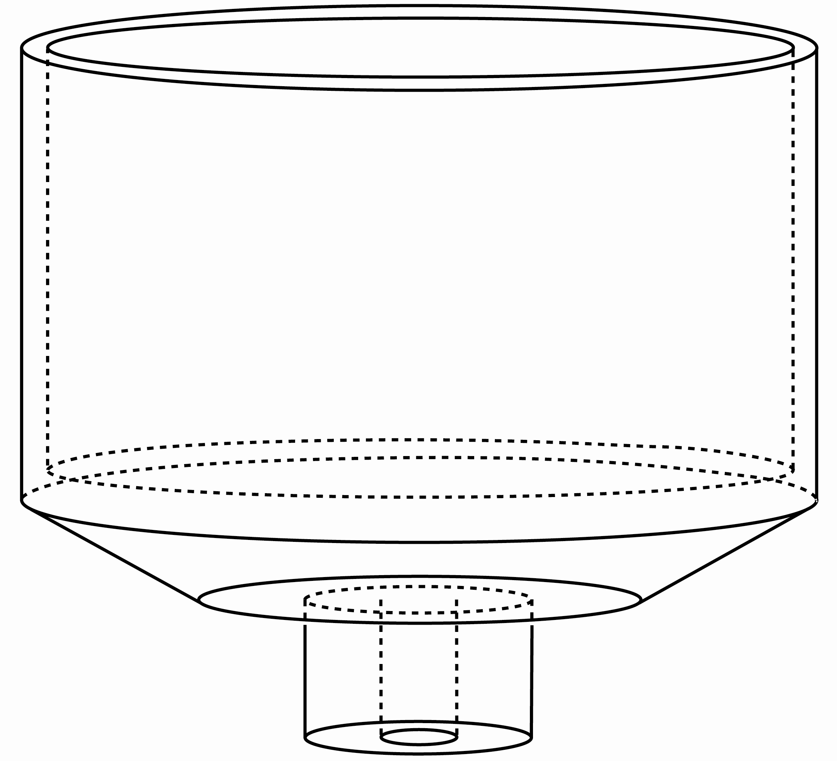
where is the shaft restoring torque stiffness, is the shaft inertia, and is the cup inertia. Optimal dimensions, giving minimal inertia and maximal resonant frequency, will be adjusted to satisfy fabrication requirements (such as wall thickness) put forth by medical Instruments staff at The University of Iowa.
Figure 18. Design of a cup to be mounted to PRV for bioreactor vibration experiments
Experiments D2.6 Drying Effects Evaluation of drying effects on accurate rheological measurement will be determined by measuring properties of each material at 1 or 10 Hz for 5 – 10 min. ⁸⁵ Indications of drying are (1) increased rheologic values over time that are greater than sample-to-sample variability and (2) crusting over the sample-air interface. To negate drying effects, solvents such as cell culture medium, distilled water, or saline, will be used to appropriately guard against drying while not affecting actual viscosity values of the tissue itself. The appropriate fluid will be applied to the sample perimeter using a micropipetor in volumes not to exceed 20% of the calculated fluid volume within the construct (30 – 100 µl). The fluid will also have a viscosity that is an order of magnitude lower than the estimated viscosity of the construct. After fluid is surrounding the construct, viscoelastic properties will be remeasured for a 5 – 10 minute interval. Accuracy of measurement will be determined by comparing measurements taken within the first 30 seconds of the initial and final tests and evaluating for significant differences between the two cases. Line fits, using Excel line fit functions, will then be applied to determine any remaining time-dependent changes in rheological measurement. The experiment will be repeated at two other frequencies to clarify frequency–dependent and time–dependent rheological changes with respect to drying. Resulting line fits will then be subtracted from frequency sweep data in subsequent measurements.
Experiments D2.7 Accuracy of rheological measurement Rheological measurement will be performed using very small amplitudes of vibration to ensure that property values are not dependent on amplitude but only on frequency. ¹¹⁴ To determine the amplitude, an amplitude sweep will be performed. Rheologic measures will be taken at 1 Hz over a broad stress or strain range such as 1 – 1000 Pa. The final amplitude for rheologic testing will be chosen at or below the point where viscoelastic measures become amplitude dependent. This generally happens at strains of 0.001 – 0.01, ten to one hundred times less than strains used during vibration exposure.
Accurate rheologic measurements of geometries will be determined in two ways. First we will use two standard materials to check for proper rheometer function. We will use a non-Newtonian standard material made by the National Institute on Standards and Testing (Gaithersburg, MD), SRM-2490 (polyisobutylene dissolved in 2,6,10,14-tetramethylpentadecane),¹¹⁶ and we will use a Newtonian standard polydymethylsiloxane (PDMS) (Brookfield Engineering, Middleboro, MA). Viscoelastic measurements of SRM-2490 should be repeatable across frequency and within 8% of previously reported values regardless of the surface roughness on the metal plates and base or the gap size used.^{85, 117} Viscosity measurements of PDMS should also be within 8% of the certified value when varying gap. The second accuracy test will be to compare our results with measurements made in different laboratories by different people, or at distant time intervals (> 3 months apart) of similar materials (Iowa, Utah, and Dr. Chan’s lab in Texas).
All measurements will be preceded by (or run concurrently) with gap loading, adhesion, and compression testing, where means and standard errors will be calculated at each frequency (N=5). Results will be used as baseline data from which to compare tissues during and after vibration exposure. Data will be used to confirm gap loading conditions and will be applied to a theoretical map of achievable strains across frequency as a function of shear elastic moduli.^{84, 117}
For each construct, experiments D2.1-D2.6 will be carried out in order to determine the lowest achievable, and describable, stress or strain and frequency. Up to five conditions will be tested to gradually reach upper limits of physiologic correlates. Raw torque and displacement will be collected 30 – 50 times within a vibrational test. Strain or stress will then be calculated with a Matlab routine and confirmed with the Malvern software. A limit will be set when strain or stress values are no longer consistent throughout a test, the sample appears tattered, or both.
Construct failure will be detected by phase contrast microscopy and large changes in viscoelastic properties (beyond standard error calculations). We will also employ selective scanning electron microscopy techniques, available through the Central Microscopy Facility at The University of Iowa. Outcomes from these experiments will be used to set stress and frequency ranges for vibration experiments pertinent to each organ (voice, ear, or skin) and each tissue construct (monolayer, hydrogel, acellular bovine construct, 2,3-DAC membranes).
Experiments D2.8 Flexible control of vibration regime (duty ratio, etc) Exposure of tissues to vibration is seldom continuous for a long period of time. In speech, vibration is turned on and off as much as 10,000 times a day. Rarely does it exceed 10s in duration, but the recovery periods can be very short (on the order of 1.0 s or less). In hearing, a loud burst of sound can be very short in duration, but some industrial and environmental noises can be continuous for long durations (perhaps hours). For vibration exposure to the hands in industrial tool use, durations tend to range from a few seconds to several minutes. Tools are switched on and off. A bioreactor needs to have the flexibility to program a variable vibration regime. Using MATLAB code, we will program the amplitude, frequency, duration, and accumulated time to change according to any specific desirable regime. Amplitude will be interpreted to mean stress or strain in the rheometer-bioreactor. The user will construct an input script as shown in the following example:
Do viscoelastic properties sweep:
Frequency=0-500 Hz;
For 1800 repetitions:
Strain=0.2; frequency =100 Hz; duration=2.0 s; duty ratio=0.5
Do viscoelastic properties sweep:
Frequency=0-500 Hz;
For 110 repetitions:
Strain=0.4; frequency=200 Hz; duration=5.0 s; duty ratio=0.1
Lift plate;
Duration=60 s
For 900 repetitions:
Strain=0.1; frequency=100 Hz; duration=4.0 s; duty ratio=0.2
Do viscoelastic properties sweep:
Frequency=0-500 Hz;
End;
The accumulated time would be 5 h. Note that the duty ratio will determine what fraction of the duration the tissue is actually being vibrated. The use of a duty ratio will make repetitive exposure easier to code. Alternatively, the user can set the duty ratio to 1.0 and turn the strain on and off for repetitive test periods. The “do viscoelastic properties sweep” is to monitor changes in material properties as described throughout the proposal. The “lift plate” instruction is critical for long exposure regimes (hours to days). It simulates physiological conditions in which full recovery can occur with minimal interference of the appliances. The tissue will be in full contact with medium. Fortunately, the rheometer plate control system already has a built-in memory of the previous plate position so that the vibration regime can be continued as programmed after the “lift plate” instruction.
To test success and limitations of the program, we will program wide ranges of stress (0-10 kPa) or strain (0.01 – 0.6), wide ranges of frequency (0.1-1000 Hz), wide ranges of duration (0-1000 s), and wide ranges of duty ratio (0-1.0). Total programmed regime will be tested over a range of 0-14 days. Over these ranges, up to 5 increments will be selected for each of the four parameters (stress or strain, frequency, duration, duty ratio). Values of parameters will then be randomized over these increments to obtain a multiple-parameter operational contour. We expect the biggest challenges to be (a) motor overheating for long duration and (b) start and stop transients for short durations. Motor overheating will be addressed by incorporating an active motor cooling system using a Neslab water circulator (Thermo Scientific, Waltham MA). Start and stop transient will be documented and their effects on accuracy of meeting the desired targets will be quantified.
Experiments D2.9 Selectability between low-frequency-large-amplitude and high-frequency-small-amplitude Software interfaces to be used for bioreactor experimentation will incorporate directives to the user for proper instrumentation setup. Determining factors are the stress and frequency range selected for vibration and for measurement. Allowable and restricted ranges, as determined by Experiments D2.2, will be identified and communicated to the user through the computer interface. Necessary locking and unlocking of drive shafts will be visually and audibly presented to the user. This is quite important because improper locking or unlocking may result in irreparable damage to the motors as well as generating unpredictable stress and frequency regimes. Additional directives to the user are needed pertaining to operating in vibration mode versus measurement mode. Measurement mode will require excess medium to be removed for a short time while vibration mode will require the sample to be immersed in cell culture medium.

D3. Extended Incubation Time
Experiments with the rheometer-bioreactor thus far have been limited to 4 hrs. The proposed system bioreactor will maintain a sterile environment for experiments lasting many days and will maintain adequate gas and nutrient exchange. The bioreactor will first generate replicable cell viability, proliferation, gene expression, and matrix production in the non-vibratory condition. These results will be compared to standard incubator conditions. When the environment is acceptable, the non-vibrating condition will serve as a control for vibration regimes.
Experiments D3.1 Maintenance of sterile environment The controlled air space of the bioreactor will be enlarged. A sterilizable tool used to manipulate bioreactor accessories coming in contact with engineered tissues will be designed and fabricated with the help of Medical Instruments staff at The University of Iowa. Sterility assessment of the chamber will be carried out by visual evaluation of cell culture medium for bacterial growth using a light microscope after bioreactor incubation for 0 – 14 days.
Experiments D3.2 Control of environmental conditions Temperature, humidity, oxygen and CO₂ content in the bioreactor chamber air and the wet environment of the cup will be controlled. Variations of these atmospheric conditions have been shown to affect cell proliferation and ECM production.^{84, 101, 102} An Omega CNiTH-i16D humidity and temperature controller will cycle a heater on an off to regulate temperature. It is also a humidity controller sensor. A Fisher and Paykel autofeed humidification system MR850 will be controlled by the Omega humidity controller or by a Fisher and Paykel temperature probe to achieve 50 – 75% relative humidity within the bioreactor. Influx of dry air from the rheometer air bearing and the heater will need to be accounted for when setting the humidifier flow rate and the circuit size. A neonatal circuit will be considered for a minimum flow rate of 250 – 300 cc/min.
A metal cover will be designed and fabricated that protects the medium-filled, tissue-containing cup from air flow within the greater bioreactor chamber. There are two sources of dry air flow in the bioreactor that are known to cause medium evaporation. The first dry air flow is directly above the cup where the upper plate fits into the torque motor assembly. This air comes from the air bearing that allows the torque motor to move without friction. The second dry air flow is the heating fan. The cover consists of two semicircular pieces similar in design to the cover made by Malvern Instruments. It will rest on the rheometer frame rather than the base cup as the current cover does.
With this approach, a single cover is used whether using the low-frequency-large-amplitude condition, or the high-frequency-low-amplitude condition; no contact with the cup or the upper plate and shaft will occur. The cover isolates the cup contents from air movement in the larger bioreactor chamber but is not completely sealed so that bioreactor humidity and CO₂ levels infiltrate the inner region. If gas and humidity conditions are suboptimal, inlet holes will be drilled into the lid to allow for direct passage of gases to the cup contents. The cover design may also require new upper plates to be fabricated that have longer stems in order to have clearance between the portals and the upper rheometer motor case.
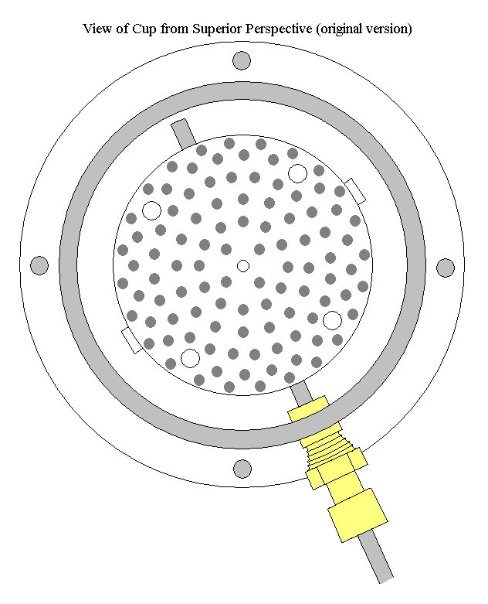
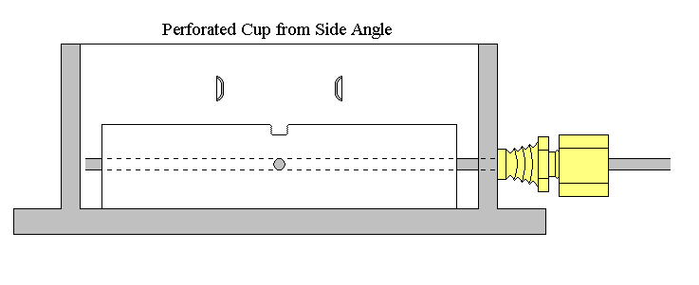
Temperature humidification and CO₂ levels will be monitored in more than one location within the bioreactor chamber. The Omega CNiTH-i16D humidity and temperature controller will measure temperature and relative humidity in one corner of the bioreactor. This will be recorded 2 – 5 times/day. DS1923 temperature/humidity logger iButtons® (Maxim Integrated Products, Inc, Sunnyvale, CA) will also be placed in two to three locations within the bioreactor to record temperature and relative humidity readings at equal intervals for up to 11 days. The resulting data will then be downloaded to a computer to determine necessary changes to the humidification and heating configuration.
Figure 19. Design of a cup with a perforated base for mass transfer of nutrients
Experiments D3.3 Mass transfer of nutrients Mass transfer of nutrients between vibration regimes will be achieved by low frequency oscillation with greater gaps between the plates, while the tissue construct remains in the bioreactor. Exchange of medium will take place every 2-3 days, when half of the medium will be replaced. Other methods of ensuring mass transfer on all surfaces of 3D constructs will be the use of a porous surface, either a hole-drilled stainless platform or a polyethylene microporous membrane. Figure 19 shows top and side view of a stainless hole-drilled platform within a cup. CO₂ gas perfusion into the cell culture medium will enter through the side of the cup.
Experiments D3.4 Cell maintenance Cell metabolism and cell death via apoptosis or trauma will be used as indicators of cell viability and validation of the bioreactor’s intended function. Environmental conditions will be monitored with the BioProfile 400 analyzer for mammalian cell culture (Nova Biomedical, Waltham, MA). Metabolites glucose, lactate, ammonium, glutamine, and glutamate, acid/base conditions pH, pO₂, and pCO₂, and electrolytes Na⁺ and K⁺ will be measured directly. Sampling will occur 2 – 5 times/day. Relative humidity will be monitored with the Omega CNiTH-i16D humidity sensor and osmolality will be recorded using the Advanced Micro-Osmometer model 3300 (Advanced Instruments, Inc, Norwood, MA). Running means and standard errors of individual quantities and yield ratio of lactate to glucose (Y_{L/G}) will be calculated for experiments lasting 0 – 14 days. Anaerobic or aerobic metabolism will then be determined as described by Obradovic et al.⁶⁹
Abrupt cell death and apoptosis will be monitored using Sytox and terminal dUTP nick-end labeling (TUNEL). Dying cells will be labeled with the vital fluorescent dye Sytox green (Molecular Probes S-7020). Any given construct will be incubated with Sytox green (diluted 1:40,000 in culture medium from a 5 mM stock) at 37ºC for 20 min, washed (5 min) with culture medium, and fixed. Quantification will be made with the use of a FLUOstar Optima automated multidetection microplate reader (BMG Labtech, Durham, NC) where absorbance and emission wave lengths are 485 nm and 528 nm respectively. Detection of double-stranded DNA breaks by TUNEL to detect apoptotic cells will be performed according to the method described by Alam et al. after fixation and permeabilization.³⁵ Biotinylated dUTP will be detected by fluorescein-labeled streptavidin with a TUNEL kit (Fluorescein In Situ Cell Death Detection Kit; Roche, Nutley, NJ) according to the manufacturer’s instructions. TUNEL results will be quantified by flow cytometry or confocal microscopy.
Cell viability in the bioreactor will be compared to that in a standard incubator under optimal conditions for 0 – 14 days. If cell viability is significantly different from the optimal condition, sterility, environment, and nutrient exchange will be adjusted and tested accordingly, as was done in the Klemuk and Titze study.⁸¹
Experiments D3.5 Tissue response to vibration-rheology Tissue response to vibration will be compared to bioreactor controls in several respects. Tissue response measures include (1) linear viscoelastic values across frequency, (2) cell orientation, (3) mRNA expression, and (4) protein staining and quantification. Linear viscoelastic properties will be measured at frequencies 0.1 – 1000 Hz during the course of a vibration experiment on the experimental and control construct. Exceptions include the monolayer and construct strips or fiber bundles where valid viscoelastic measurements are not possible using standard rheometric methods. A frequency sweep, lasting approximately 1 – 10 min, will be taken initially and at least one other time by the end of the experiment. Amplitudes of vibration and duration of the frequency sweep will be at 10 times less than vibration, and identical testing will occur on each control sample. In this way, vibration-influenced changes to rheology will be isolated.
Experiments D3.6 Tissue response to vibration-gene expression Changes in various matrix-associated genes (elastin, alpha 1(I) procollagen, fibronection, MMP-1) and proteoglycan/ hyaluronic acid-associated genes (HA synthase 2, hyaluronidase, CD 44, fibromodulin, decorin) normally expressed in the human vocal fold will be examined in response to vibratory strain conditions. The same genes will be assessed for the dermal construct. TaqMan Preamplification kit (Applied Biosystems, Carlsbad, CA) will be used to amplify cDNA template in order to test multiple genes’ expression levels from a single construct. TaqMan gene expression assays will then be used for real time PCR technique. Primers and probes will be ordered directly from Applied Biosystems. 18S is a constitutively expressed gene and will be included as a control. Real time PCR will be performed by using the TaqMan instrument 7500 sequence detection system from the DNA core facility at the University of Iowa. Data will be normalized based on 18S densitometry levels. Experiments will be run in triplicate, and gene expression levels will be statistically compared by ANOVA using Tukey’s method for post hoc testing with p<0.05 considered significant.
Experiments D3.7 Tissue response to vibration-protein expression Protein expression will be determined using Western blot. For Western blot analysis of elastin, collagen I, collagen III, collagen IV, fibronection, MMP-1, hyaluronidase, CD 44, fibromodulin, and decorin, total protein extract will be collected using radioimmunoprecipitation buffer (Pierce Biotechnology Inc., Rockford, IL, USA), supplemented with a protease inhibitor cocktail (Sigma, catalogue no. P8340), and two phosphatase inhibitor cocktails (Sigma, catalogue no. P2850, P5726). Protein concentrations will be determined using a standard Bradford assay; 50 μg of each sample will be loaded onto a 12% polyacrylamide gel and will be run at 200 V for 1 h. The protein will then be transferred to a nitrocellulose membrane at 100 mAmp at 4 °C for 12 h. After transfer, the membrane will be blocked in a milk solution (4% non-fat dry milk and 0.3% Tween-20 in 1× PBS) for 2 h at room temperature. The membrane will then be incubated with the appropriate primary antibody for 2 h at room temperature. After primary antibody exposure, the membrane will be washed and will be incubated with an appropriate infrared secondary antibody for 45 min at room temperature. Following removal of secondary antibody, protein will be detected with the use of an Odyssey infrared imaging system (LI-COR Biotechnology, Lincoln, NE, USA) at the department of Anatomy and Cell Biology at The University of Iowa. Densitometry analysis will be performed using Odyssey infrared imaging software (LI-COR Biotechnology). Since there is no commercial Hyaluronic acid synthase 2 antibody available, HA will be measured with an HA enzyme-linked immunosorbent assay kit (Echelon Biosciences. Salt Lake City. Utah). Protein expressions will be performed in triplicate. Results will be statistically compared using analysis of variance (ANOVA) using Tukey’s method for post hoc testing with p<0.05 considered significant to study differences between groups.
Experiments D3.8 Tissue response to vibration-cell adhesion limits Cell adhesion limits of vocal fold and dermal cells, with and without inertia, will be tested using the film or monolayer geometry and specially designed appliances. This general protocol will be similar for all of geometries. Stress regimes will be determined by vocal dosage studies (section C2) and preliminary monolayer studies (C1). An example is to push the upper stress limits at 2000, 3000, 4000, and 5000 Pa and 100 Hz. The plate radius R_{e} and the gap size d will be chosen based on experiments D2.1 and D2.4. A duty cycle (on-off regime) of 0.5 will be selected (10 s on, 10 s off), and each stress exposure will last up to 8 hrs. Programming of these settings is discussed in D2. Incubation time prior to vibration exposure may affect cell adhesion or cell orientation following vibration exposure. For this reason, circular glass coverslips will be seeded with cells and incubated for a predetermined time depending on the degree of desired adhesion, 30 min to 18 hrs (5% CO₂, 37°C, > 95% RH). The coverslip will then be mounted and vibrated as previously described. A corresponding control seeded coverslip will be used in a parallel rheometer-bioreactor without vibration exposure.
H & E (hematoxylin & eosin) will be used to stain the cells after exposure to mechanical stress. Cell counting and cell orientation will be conducted with the aid of the custom-made photoetched cover slip. Digital images of the cells, overlaid with the grid, will be taken with an Olympuse BX-51 inverted microscope at 2X or 10X (Central Microscopy Research Facilities, The University of Iowa), and cells will be counted. Experiments will be run in triplicate, results will be statistically compared using analysis of variance(ANOVA) using Tukey’s method for post hoc testing with p<0.05 considered significant to study differences between groups.

D4. Extending the Stress Application to Compound Stresses and Wave Propagation
Viscoelastic waves propagate in tissues exposed to vibration if the wavelength does not substantially exceed tissue dimensions. Owing to the nature of excitation and boundary conditions on tissue structures in organs like the ear and the larynx, the waves are almost never simply longitudinal or transverse. In contrast to ultrasonic waves that are mostly compressional, shear is ubiquitous in all sonic frequency deformations. Often the waves are surface waves (also known as Rayleigh waves), as on the skin of the hand and the edge of the vocal folds. Basilar membrane waves are primarily transverse, but deformation is heavily influenced by the liquid drag of the cochlear fluids. Our bioreactors will have the ability to excite waves in tissue samples under viable conditions, so that spatially-varying stresses in the form of standing or traveling waves can be applied.
Experiments D4.1 Stress application for transverse waves Several cup inserts will be designed and manufactured for transverse wave excitation in tissue constructs. Figure 21 shows the basic design. A cup insert, referred to as a variable diameter mounting ring, will be bolted to the base of the cup. It will be machined with titanium. In the center of the cup, the rotating shaft and plate of the axial-mode rheometer will have several slots and fastening screws to clamp tissue constructs in the form of ribbons, fibers, and fiber bundles.
Similar slots and clamping screws will be machined into the mounting ring. Mounting rings of several diameters will be fabricated so that the length of the tissue construct can be varied as required. For a vocal ligament, for example, the tissue length is about 10 mm. For a basilar membrane, it is 10-30 mm depending on the animal. In future developments, the mounting ring could be partitioned (with separate radii for each tissue sample) so that different longitudinal tension could be applied with a micrometer attachment, but such a development is beyond the current scope.
As the plate rotates, the tissue constructs will be exposed to transverse vibration at the driving end. The boundary condition at the other end can be varied by different constraints. The material can be either pinned or clamped. If pinned, the displacement (but not the derivative of the displacement) will be zero. If clamped, both the shape and the derivative will be zero.
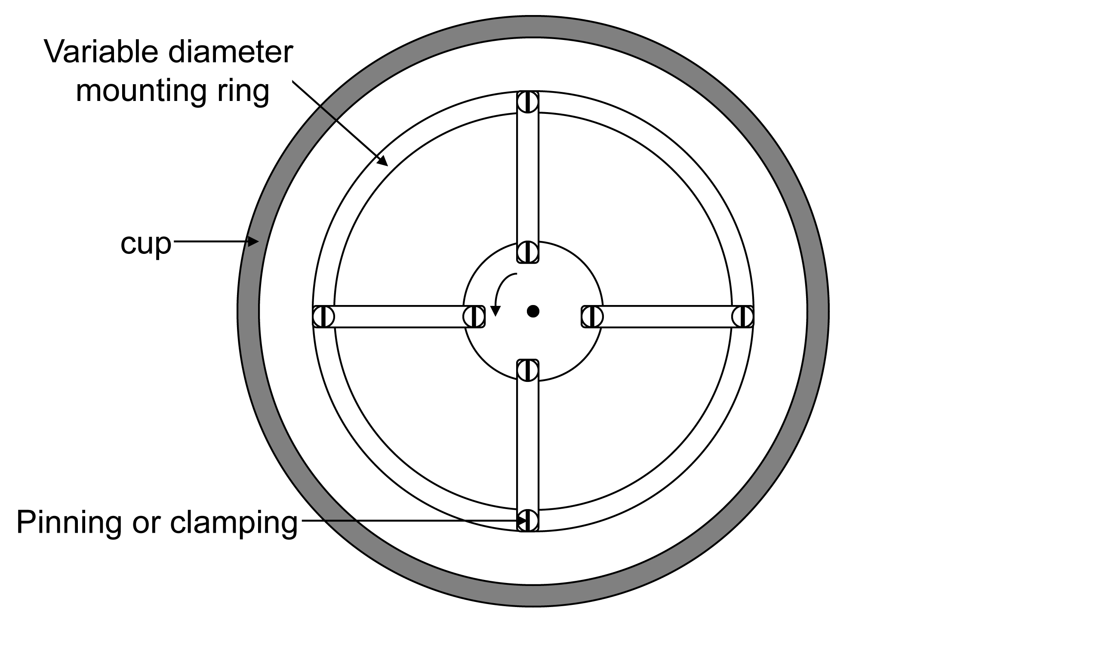
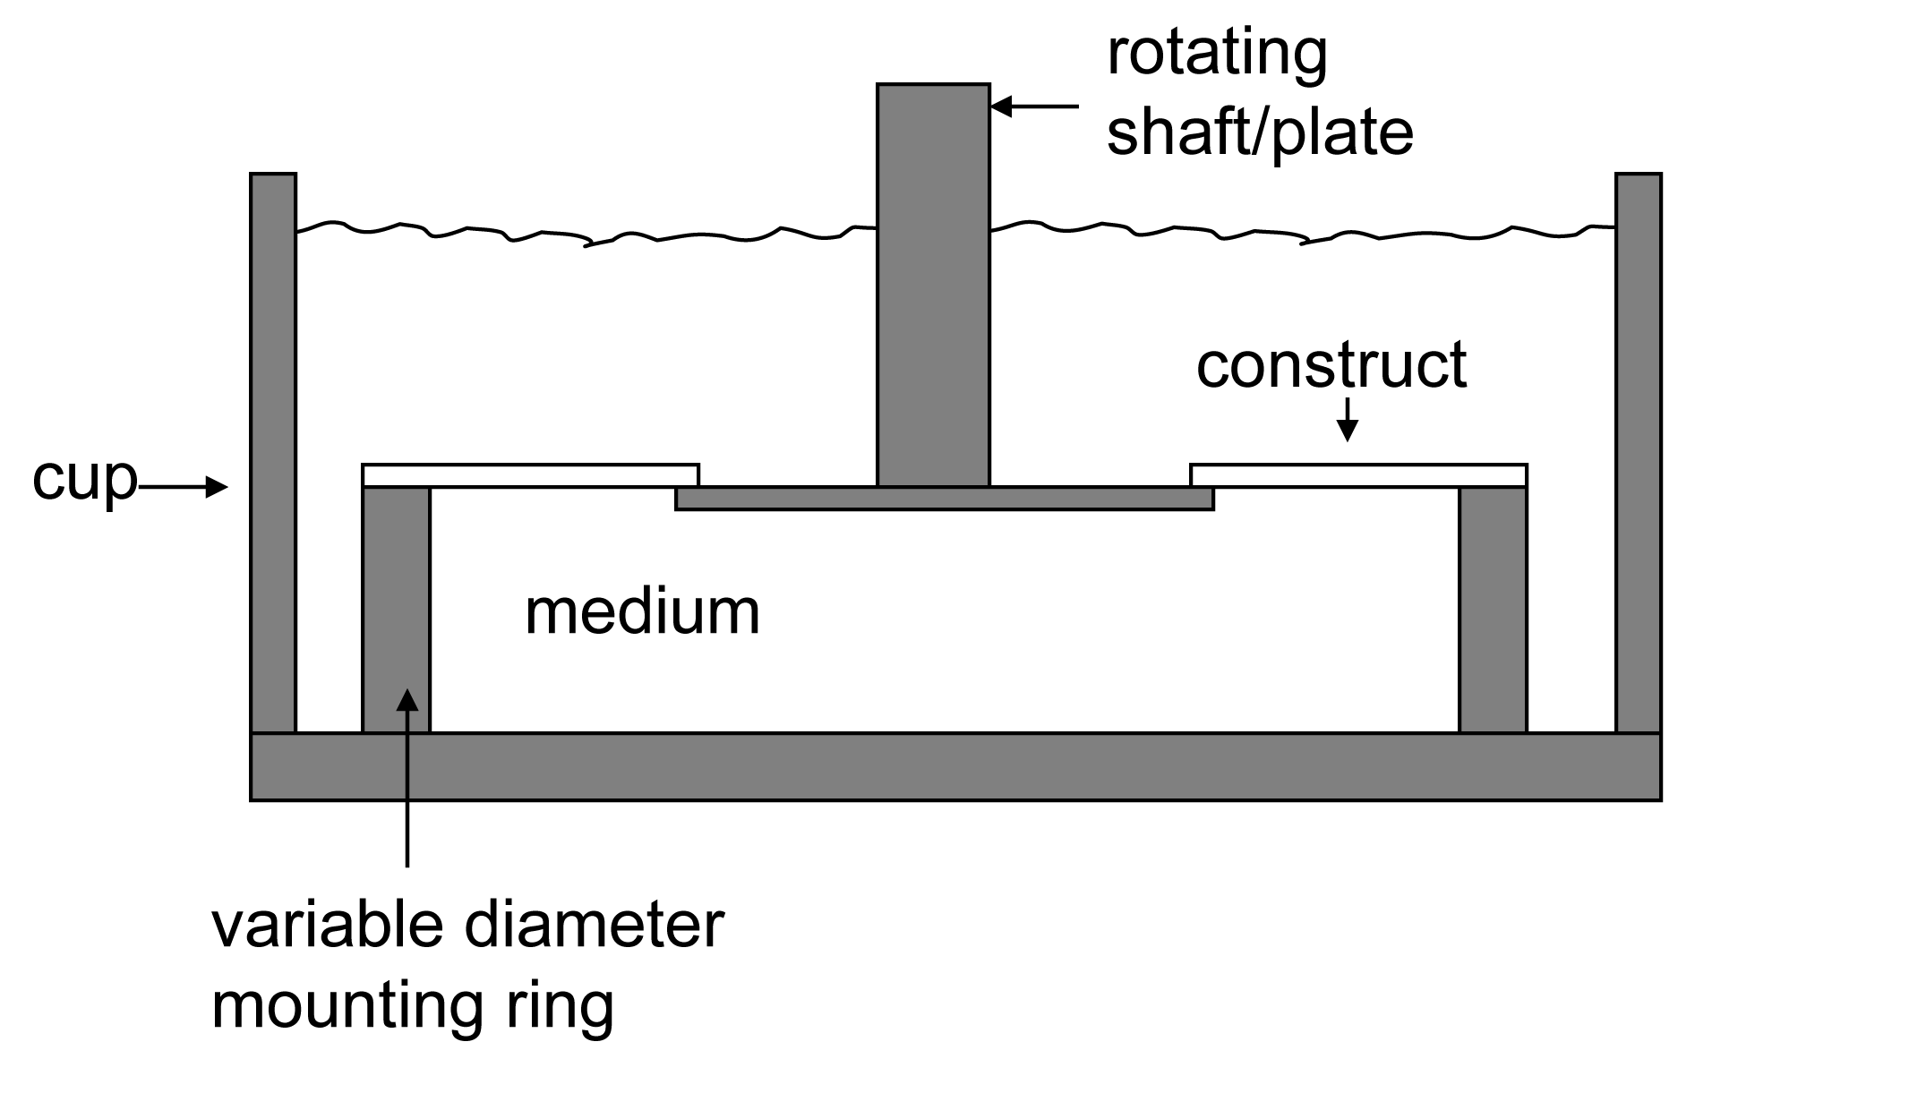
Experiments D4.2 Frequency response at driving point The fundamental improvement of the rheometer-bioreactor over the earlier design in the Preliminary Studies is that displacement of the rheometer shaft is a known quantity for any applied load, if the strain-control mode is used. Alternatively, for the stress-controlled mode, applied shear stress is a known quantity. What needs to be determined is the range of loads that the cup insert with its multiple tissue attachments will impose on the rheometer over the desired frequency range. This will vary with the type of material, the longitudinal tension applied to the constructs, and the added inertia of the moving parts. The range of driving point displacements will be determined as a function of tissue geometry and longitudinal stress.
Figure 21. Cup schematic for vibrating ribbon constructs
The basic equation of motion is
where is the angle of rotation of the inner plate, I is the inertia of the system, R is the resistance to rotation, K is the rotational stiffness, and T is the applied torque. Within tissue constructs, the wave equation applies,
where ρ is tissue density, is transverse displacement, D is the fluid drag on the tissue, σ is the longitudinal stress, E is the Young’s modulus, and is the radius of gyration (for bending moments in the tissue). The two equations are coupled to each other because , where r is the radius of the rotating plate.
A frequency response curve will be obtained empirically for , the ratio of angular displacement to applied torque. This frequency response will vary with tissue parameters σ, E and . A variety of fibers, membranes, and ribbon constructs will be used to test the frequency response sensitivity to tissue parameters.
Experiments D4.3 Determination of input impedance Four exponential wave solutions of the form
satisfy Equation .¹¹⁸ Substitution of Eq. into Eq. yields the characteristic equation for wave propagation,
which has four algebraic solutions for γ, known as the wave number or propagation constant,
With four wave numbers (γ₁, γ₂, γ₃, and γ₄ according to the ± sign combinations in Eq. ), the complete solution of Eq. is
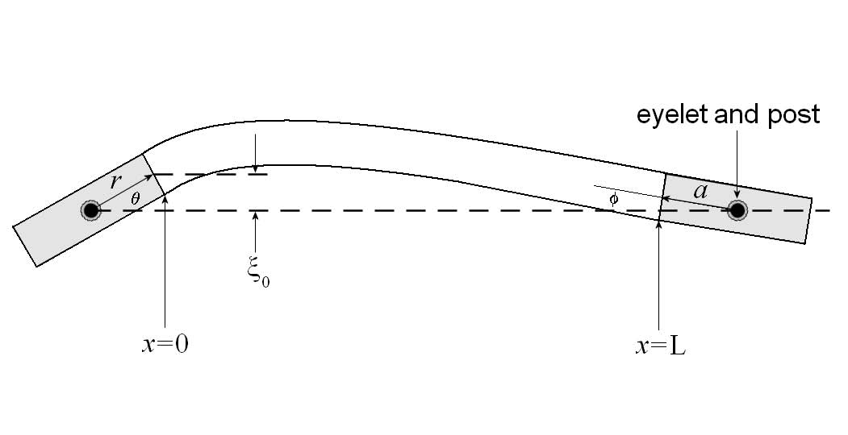
where A₁, A₂, A₃, and A₄ are coefficients to be determined by the boundary conditions. (Figure 22).
Figure 22. A strip of material in vibration
The driven end is on the left. Both ends are constrained to bend or rotate around a pivot point.
An input impedance of the tissue construct array (4 strips in Figure 21) will be defined as the ratio of the Fourier transformed stress σ at the driving part (x=0 in Figure 22) to the Fourier transformed strain rate at the same point. As this input impedance varies with frequency, the peaks in the impedance curve will determine the resonance conditions produced by standing waves on the tissue constructs.
Experiments D4.4 Indirect determination of viscoelasticity Analytical and computational methods can be applied by users to relate changes in resonance frequencies and bandwidths of the impedance curves to changes in the elastic and viscous moduli of the tissue constructs. In our work, a sensitivity analysis will be conducted (empirically and analytically) to determine what degree of change in the elastic modulus G’ and the viscous modulus G’’ can be detected with the instrumentation and the calculated impedance curves.
D5. Timeline and milestones
Each aim will be targeted in each year of the granting period, with advances and extensions progressing annually. The progression is simple to complex in terms of geometry, function, wave type, and short to long term dosage exposure. Table 2 shows which advancement or extension will be addressed in a given year. Milestones will demonstrate rheometer-bioreactor functionality given conditions of a given year.

Table 2. Milestones and time frame
Milestones for functional rheometer-bioreactor | Year 1 | Year 2 | Year 3 | Year 4 | Year 5
Milestones for functional rheometer-bioreactor | Supports 3 living geometries up to 8 h with and without vibration | Supports 4 living geometries up to  24 h with and without vibration | Supports 5 living geometries up to 3 d with and without vibration | Supports 5 living geometries up to  14 d with and without vibration
Geometry | Fluids  Films  2,3-DAC disk and ribbon  Gel | 2,3-DAC disk and ribbon  Gel  Bovine ribbon  Tympanic membrane  Dermal disk | 2,3-DAC disk and ribbon  Gel  Bovine ribbon  Basilar membrane  4-6 d rat cochlea  Dermal disk | 2,3-DAC disk and ribbon  Gel  Bovine ribbon  4-6 d rat cochlea  Dermal disk  Dermal ribbon | Same as Year 4
Function | Extend frequency  Extend amplitude  Begin programming Build PRV cup | Program prototype (Matlab)  Automate | Expand program  Increase automation time  Test numerous vibration protocols  Evaluate Cell response to vibration
Accumulated time | 0-8 hrs | 8-24 hrs | 24 h - 3 d | 3 - 14 d
Compound stresses | Build variable diameter mounting ring | Determine frequency response | Determine input impedance | Evaluate indirect linear viscoelastic measurement

